|  |  |
| --- | --- |
| \\VFILERDPI\DPI-Home\OBRIENR2\My Documents\Downloads\PP logo.jpg |  |
| **COUNCIL ASSESSMENT REPORT**  SOUTHERN REGIONAL PLANNING PANEL | |

|  |  |
| --- | --- |
| PANEL REFERENCE & DA NUMBER | PPSSTH-190 – 10.2022.39717.1 |
| PROPOSAL | Demolition of buildings, Three (3) Educational Buildings - Junior, Senior, Music & Drama Centre - Tree Removal, Carparking and Landscaping - Trinity Anglican College Expansion. |
| ADDRESS | Lot 71 DP 1048990, Lot 1 DP1070397 located at 421 Elizabeth Mitchell Drive Thurgoona |
| APPLICANT | Mr. Tom Carmody |
| OWNER | The Anglican Schools Commission Incorporated |
| DA LODGEMENT DATE | 10 October 2022 |
| APPLICATION TYPE (DA, Concept DA, CROWN DA, INTEGRATED, DESIGNATED) | Development Application  ‘Integrated Development’ pursuant to Section 4.46 of the Act and Section 100B of the Rural Fires Act. |
| REGIONALLY SIGNIFICANT CRITERIA | Item 5 of Schedule 6 of State Environmental Planning Policy (Planning Systems) 2021 for an Educational Establishment development that has a capital investment value of more than $5 million |
| CIV | $31,200,000.00 - Rounded (excluding GST) |
| CLAUSE 4.6 REQUESTS | N.A. |
| KEY SEPP/LEP | SEPP (Resilience and Hazards) 2021  SEPP (Planning Systems) 2021  SEPP (Industry and Employment) 2021  SEPP (Biodiversity Conservation) 2021  SEPP (Transport and Infrastructure) 2021  Albury Local Environmental Plan 2010 |
| TOTAL & UNIQUE SUBMISSIONS KEY ISSUES IN SUBMISSIONS | One (1)  Lighting, Stormwater, Use of multi-purpose courts, landscaping details |
| DOCUMENTS SUBMITTED FOR CONSIDERATION | As per Plan Version and reports Prepared By sections below |
| SPECIAL INFRASTRUCTURE CONTRIBUTIONS (S7.24) | N.A. |
| RECOMMENDATION | Approval |
| DRAFT CONDITIONS TO APPLICANT | Provided 22 March 2023. |
| SCHEDULED MEETING DATE | 5 April 2023 |
| PLAN VERSION | |  |  |  |  | | --- | --- | --- | --- | | Drawing Number | Description | Revision | Date | | TP-001 | Junior School Existing and Demolition Site Plan | P11 – TP Amendment | 15/02/2023 | | TP-J060 | Junior School – Existing and Demolition Landscape Plan | P5 – Town Planning Update | 06/02/2023 | | TP-A060 | Arts Precinct – Existing and Demolition Landscape Plan | P6 – TP Amendment | 15/02/2023­ | | TP- S060 | Senior School – Existing and Demolition Landscape Plan | P6- TP Amendment | 15/02/2023 | | TP-S062 | Sports Courts – Existing & Demolition Landscape Plan | P2 – TP Amendment | 15/02/2023 | | TP-100 | Proposed Site Plan | P10 TP Amendment | 09/02/2023 | | TP-A110 | Music & Drama Centre Proposed Floor Plan | P6 – DA Issue Update | 12/09/2022 | | TP-A130 | Music & Drama Centre Proposed Roof Plan | P5 – DA Issue | 09/09/2022 | | TP-A200 | Music & Drama Centre Proposed Elevations | P4 – DA Issue | 09/09/2022 | | TP-A201 | Music & Drama Centre Proposed Elevations | P4 – DA Issue | 09/09/2022 | | TP-J110 | Junior School – Proposed Ground Floor Plan | P12 – Town Planning Update | 27/01/2023 | | TP-J111 | Junior School – Proposed First Floor Plan | P9 – Town Planning Update | 27/01/2023 | | TP-J130 | Junior School – Proposed Roof Plan | P7 – Town Planning Update | 27/01/2023 | | TP-J200 | Junior School – Proposed Elevations | P6 – Consultant Issue | 20/10/2022 | | TP-S110 | Senior School – Proposed Ground Floor Plan | P6 – Town Planning Update | 27/01/2023 | | TP-S111 | Senior School – Proposed First Floor Plan | P6 – Town Planning Update | 27/01/2023 | | TP-S130 | Senior School – Proposed Roof Plan | P4 – Town Planning Update | 27/01/2023 | | TP-S200 | Senior School – Proposed Elevations Sheet 1 | P4 – Town Planning Update | 27/01/2023 | | TP-S201 | Senior School – Proposed Elevations – Sheet 2 | P4 – Town Planning Update | 27/01/2023 | | TP-J061 | Junior School – Proposed Landscape Plan | P7 – Town Planning Update | 06/02/2023 | | TP-A061 | Arts Precinct – Proposed Landscape Plan | P5 – Town Planning Update | 06/02/2023 | | TP-S061 | Senior School – Proposed Landscape Plan | P5 – Town Planning Update | 06/02/2023 | | TP-S063 | Sports Courts – Proposed Landscape Plan | P2 – TP Amendment | 09/02/2023 | |
| PREPARED BY | * Quantity Surveyors Report, prepared by Currie & Brown * Architectural Plans, prepared by Vincent Chrisp Architects * Landscaping Plan, prepared by Vincent Chrisp Architects * Bushfire Risk Assessment, prepared by Bushfire Planning Services Pty Ltd * Traffic Impact Assessment, prepared by One Mile Grid * Flora and Fauna Assessment, prepared by Steve Hamilton * NSW Design Quality Principles in Schools Compliance Table, prepared by Habitat Planning * Planning Compliance Table, prepared by Habitat Planning * Geotechnical Report, prepared by Civil Test * Concept Stormwater Drainage Plan, prepared by JCA Land Consultants * Tree removal Plan and Table – prepared by Vincent Crisp Architects and Habitat Planning |
| DATE OF REPORT | 3 March 2023 |

**EXECUTIVE SUMMARY**

This application has been lodged by Tomahawk Property Pty Ltd on behalf of the Victorian Anglican Schools Commission for the redevelopment of the Trinity Anglican College - Thurgoona Campus at Lot 71 on DP1048990, addressed as 421 Elizabeth Mitchell Drive Thurgoona. The development application seeks approval for the redevelopment of Trinity Anglican College and includes the demolition of a number of structures, construction of three (3) new school buildings, bus drop off area and driveways, multi-sports courts, signage, tree removal, earthworks and retaining walls.

The development is for a type of educational establishment that has a Capital Investment Value (CIV) greater than $5 Million. Consequently, the development is “Regionally Significant Development” under the provisions of the State Environmental Planning Policy (Planning Systems) 2021.

The design response satisfies the intent of the provisions of the applicable Environmental Planning Instruments and will result in a positive development outcome in terms of social, environmental, and economic impacts. Specifically, the development represents a high-quality development that will provide an upgrade and expansion to an existing educational establishment which is an important service for the community.

1. **THE SITE AND LOCALITY**
   1. **The Site**

The subject site, identified in the location map below, comprises the existing Trinity Anglican College -Thurgoona Campus, which is located at 421 Elizabeth Mitchell Drive, Thurgoona. The site is irregular in shape and has a total area of 10.14 hectares. The topography of the land is gently undulating and slopes downwards (downslope 0-5 degrees) towards the adjoining watercourse located to the north.

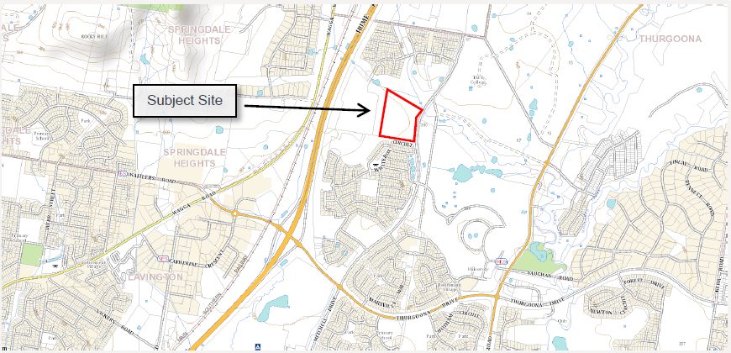

Locality Plan

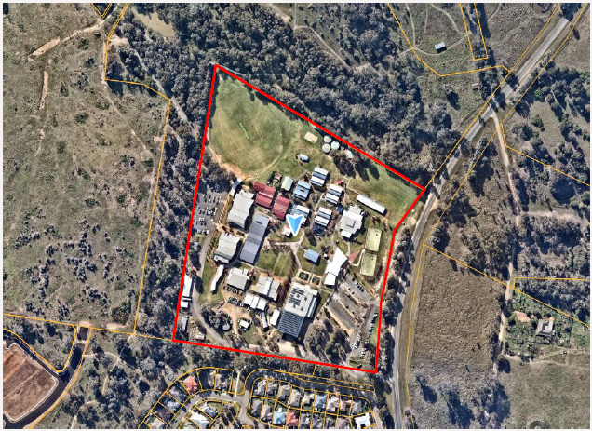

Site conditions

* 1. **The Locality**

The site is bound by Elizabeth Mitchell Drive to the east and AlburyCity owned land to the north, south and west which is C3 – Environmental Management land. The precinct is located approximately 1.2 km north-west of the Thurgoona B2 – Local Centre zone.

More generally, land to the north and south of the college is predominantly zoned R1 General residential and has been developed primarily with detached dwelling houses. Land to the west is zoned residential and is currently undeveloped however contains development approval for a residential subdivision. Land to the north-east, east and south-east is zoned SP2 Infrastructure – Educational Establishment, however only a portion of the SP2 land has been developed to the south-east for the purpose of Charles Sturt University – Albury - Wodonga Campus. The area is also categorised by several environmental corridors which are contained within the C3 Environmental Lands zone and run through the R1 and SP2 zoned lands.

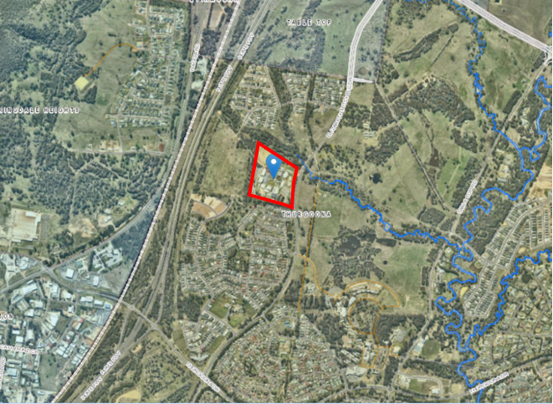

Aerial image of locality.

1. **THE PROPOSAL AND BACKGROUND** 
   1. **The Proposal**

The application proposed the redevelopment of Trinity Anglican College – Thurgoona Campus at 421 Elizabeth Mitchell Drive, Albury. The development includes demolition of several structures, construction of three (3) new school buildings (junior school, senior school and music and drama centre), bus drop off area and driveways, multi-sports courts, signage, tree removal, earthworks and retaining walls.

Specific details in relation to the proposal are outlined below.

Demolition

The application seeks to demolish and remove, within the proposed building footprint a number of existing buildings and structures, including:

* transportable buildings,
* above ground water tanks,
* basketball courts,
* sealed areas; and
* kiss and drop facility located adjacent to the front carpark.

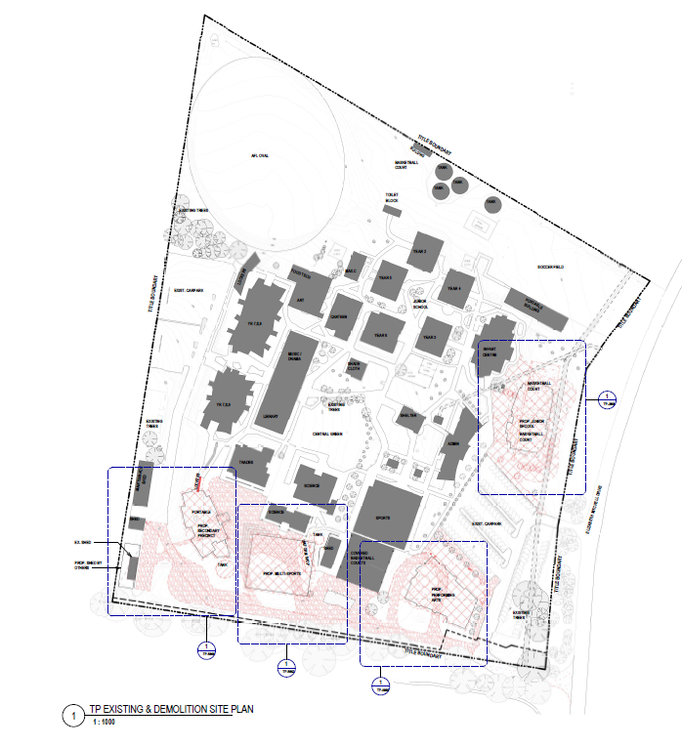

Junior School (K-2) Building

A new Kindergarten to Year 2 (K-2) junior school building (‘Junior Precinct’) is proposed in the eastern portion of the site adjacent to Elizabeth Mitchell Drive. An amendment to the application submitted on 9 February 2023 altered the design and layout of the proposed building. The amendment to the building submitted on 9 February 2023 did not alter the total number of students and staff originally proposed by the application.

The building will be located in the area currently occupied by the existing basketball courts and will be setback 15.9 metres from the adjoining front property boundary and have a total area of 2,367m2.

Externally, the new building will be two storeys in height and will have an overall height of 10.12 metres above ground level. Similarly, the building will have an overall length of 50.83 metres and a width of 31.92 metres.

The proposed junior school building as amended comprises of the following:

* Twelve (12) General Learning Areas (GLAs) (classrooms) ranging in size from 82m2 to 89m2. Six (6) located on the ground floor, six (6) located on the first floor.
* Associated store rooms extending off from GLA rooms.
* Staff, interview and education support rooms.
* Shared circulation space.
* Kitchen
* Toilets
* Lift and Stairwells;
* Covered balconies.

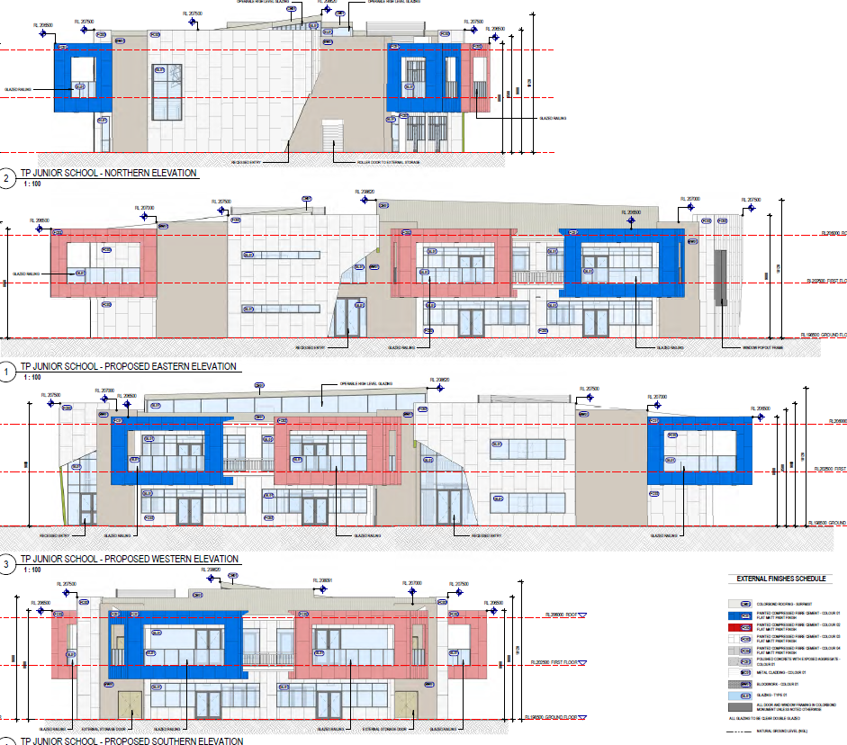

Junior School building elevations. (Artist impression not provided).

Senior School Building

A senior school building (‘Secondary Precinct’) is proposed in the south-western portion of the site adjacent to existing trades and science buildings. The proposed new building will be located in the area currently occupied by an informal gravel car park area and will have a total area of 1,632m2 and be set back 35.6 metres from the closest (western) boundary of the site.

The building is proposed to be two storeys in height and will have an overall height of 10.11 metres above ground level an overall length of 45.23 metres and a width of 23.57 metres.

The proposed senior school building comprises of the following:

* twelve (12) GLA’s ranging in size from 66m2 to 71m2. Six (6) located on the ground floor, six (6) located on the first floor.
* shared circulation area;
* range of shared facilities and services including toilets (including accessible toilets) and a common lift and stairwell.

Two staff rooms are also proposed at the northern end of the building at both the ground floor.

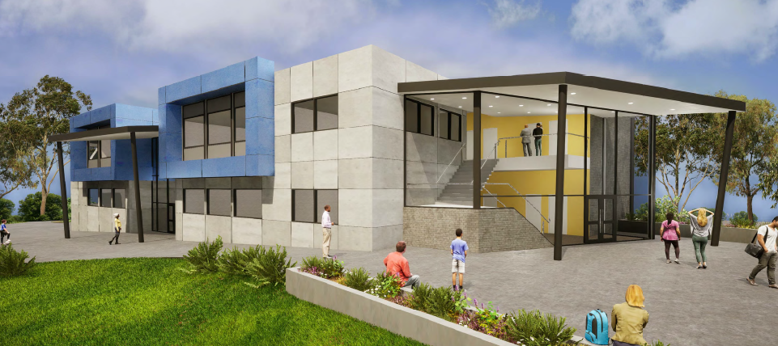

Artist impression of Senior School building.

Music and Drama Centre

A music and drama centre is proposed in the south eastern portion of the site adjacent to Elizabeth Mitchell Drive and the site entrance. The building will be located in the area currently occupied by the previous bus parking area and will have a floor area floor area of 1,323m2 and be setback 17.87 metres from the southern boundary and 49.71 metres from the front property boundary. The building will be single storey and will have an overall height of 8.61 metres above ground level. The building will have an overall length of 48.98 metres and a width of 38.05 metres.

The proposed music and drama centre comprises of the following:

* four (4) classrooms (2 dance and 2 music) each with an area of 100m2,
* large multi-purpose space, which has provision to be reconfigured via the operation of a moveable internal wall.
* breakout practice rooms,
* internal circulation areas,
* staff room,
* amenities (kitchen and toilets),
* large foyer area adjacent to the multipurpose space, which is accessed via the covered main entry.

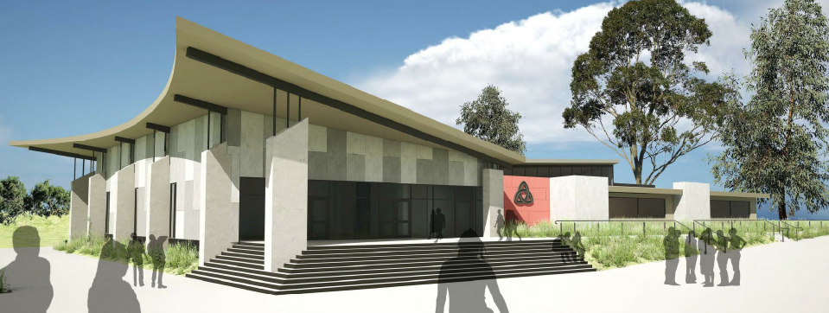

Artist impression of Music and Drama centre.

Building Materials/Design

All buildings will be constructed of a variety of materials and finishes including brickwork/blockwork, metal cladding, polished concrete with an exposed aggregate finish, Colorbond, glazing, as well as compressed fibre cement painted in the schools’ colours (red, white and blue).

In order to reduce building bulk and scale, the design of the buildings incorporate skillion roofing and contain covered awnings and a covered front door to ensure all weather protection. Buildings will incorporate a large number of windows and doors to break up the appearance, as well as to provide passive surveillance to surrounding land.

Multi-purpose Sports Courts

Multi-purpose sport courts are proposed as part of the development to replace the existing basketball courts which are proposed to be demolished in order to construct the new junior school building. The new multi-purpose courts will be located to the south of the existing science building adjacent to the new bus bay area.

These courts will have overall dimensions of 36.6 metres x 42.7 metres and will consist of a sealed surface with associated line-marking that can be reconfigured to suit the type of sport proposed. The courts will be enclosed by a 3.6 metre high black chainmesh fence.

Retaining walls built into the natural slope in the north-west corner to allow for tired seating/spectator viewing. To avoid amenity impacts, the courts will have no external lights and courts will be used during school hours, generally, between 8:00am and 4:30pm. All night time sports will be played within the existing school facilities.

Bus drop-off and pick-up area

The bus drop-off and pick-up area is proposed to be relocated along the proposed upgraded southern driveway which will provide separation between the bus area from the parent parking areas. A new round-about is proposed at the western end of the driveway to allow vehicles buses to enter and exit the site in a forward direction and to ensure students do not need to cross any roads to access bus bays.

Earthworks and retaining walls

Proposed earthworks consist of leveling of the development sites. Proposed retaining walls include:

* Tiered seating, in the north-west corner of the multi-sports courts as per plans which state the following: ‘*tiered seating 450mm high timber sleeper retaining wall with galvanized H section post and timber sleeper rail. Infill crushed rock landings. Tiered seats to diminish into natural landscape slope’.*
* retaining wall immediately adjacent to a proposed new storage shed (by others) in the south corner of the property. This area is proposed to be used for rubbish storage and a collection area.
* retaining wall to the south of the junior school precinct.

Tree removal and landscaping

The development requires the removal of 19 planted trees, 16 of which are non-native (primarily *prunus*), three (3) of which are native, (two River she-oaks and a yellow gum).

Development approval is only required for the removal of 14 trees, as five (5) of the trees do not require approval as they do not meet the size requirements of control (iii)(a) of Section 5.2 of the DCP.

Landscape plans have been provided with the application showing proposed landscaping/planting.

Signage

The application seeks development consent for one business identification sign (school logo). The sign will be affixed to the northern elevation of the new music and drama building. It is noted that two signs were proposed in the original application, however amended plans submitted on 9 February 2023 removed the proposed signage from the junior school building. It is noted that the SEE was not updated to reflect this change.

The proposed sign on the music and drama building will consist of a flush wall sign and will be similar to the existing logos erected on the main administration building located at the front of the site. The sign will be non-illuminated and painted in the school colours (red, white and blue).

Full details of the proposal are shown in the development and landscape plans (included in attachment 1 and 2 respectively) and described in the Statement of Environmental Effects (included as attachment 3) except where modified by Cover letters and amended plans response and tree removal works (included in attachment 4 and 5 respectively).

**Table 1: Development Data**

|  |  |
| --- | --- |
| **Control** | **Proposal** |
| Site area | 10.14 hectares |
| GFA | 5,322m2 |
| Clause 4.6 Requests | No |
| No of apartments | N.A. |
| Max Height | 10.12m |
| Car Parking spaces | 224 car parks to the front of the site and 94 to the rear) |
| Setbacks | 15.684 to Eastern boundary (front), 17.876 to Southern boundary, >35m to Western boundary. |

* 1. **Background**

A pre-lodgement meeting was held prior to the lodgement of the application on 1 September 2022 where various issues were discussed. A summary of the key issues and how they are addressed is outlined below:

|  |  |  |
| --- | --- | --- |
| No. | Issue | Design Response/Comment |
| 1 | Background and overview of the growth of the school and previous development options to cater for the long-term needs of the school, including the acquisition of the Somerset Rise Site. | The applicant has confirmed that the projected numbers of staff and students of which this development will accommodate represent the future capacity of the school.  Any further development on the site will likely be to replace existing buildings/assets and will not result in more staff or students. |
| 2 | It was confirmed that the development would not be classified as State Significant Development (SSD) as it did not involve the construction of a new school or school campus. | Noted. |
| 3 | The works are however classified as ‘Regionally Significant’ as they involve works to an educational establishment with a Capital Investment Value of more than $5M. | The application will therefore need to be determined by the Southern Regional Planning Panel. |
| 4 | The application will be supported by other technical sub-consultant reports including traffic, biodiversity and bushfire. | Traffic Impact Assessment, Bushfire Report and Test of Significance provided with application. |
| 5 | It was requested that the panel be contacted to arrange a time to convene to avoid delays. Council recommended a potential option of providing a fly through/video of the area of works to avoid the need for a site inspection. | Not provided. |
| 6 | Council’s traffic officer advised that the Traffic Impact Assessment (TIA) would need to address the new bus drop off and pick up arrangements, as well as addressing the mixing of large and light vehicles. Matters regarding car parking and kiss and drop will also need to be assessed. | A Traffic Impact Assessment Report (TIA) has been prepared by One Mile Grid and is provided in attachment 6. The TIA addresses the separation of the bus parking from visitor/drop off/staff parking areas.  It is noted prior to lodgement of the application internal traffic matters were addressed separately, such as one way traffic flow, re-marking of carparks and removing access to the site from the northern access point on Elizabeth Mitchell Drive.  As a result the plans provided do not show current parking conditions. However, no changes to the existing onsite car park arrangement are proposed as part of the application.  The application only proposes changes to bus parking areas and the upgrade of internal roads including a roundabout to allow for bus turning within the site. |
| 7 | Council’s environmental planner requested that a flora and fauna assessment be undertaken. Given that the land is biodiversity certified, this assessment would largely be limited to a report detailing the proposed trees to be removed. It was recommended that the report address the need for the tree removal works, including options to avoid or mitigate impacts. Landscaping details would also need to be provided as part of the application. | Flora and Fauna Assessment submitted and landscape plan provided with application. |
| 8 | The application will be referred to the NSW Rural Fire Service as it represents Integrated Development as the development represents a Special Fire Protection Purpose and requires approval under Section 100B of the Rural Fires Act 1997. | Noted.  The application is ‘Integrated Development’  pursuant to Section 4.46 of the Act and Section 100B of the Rural Fires Act. |
| 9 | It was recommended that a review of Essential Energy’s network portal be undertaken to determine whether the development needs to be referred to this authority. | Noted. Application referred to Essential Energy who provided general comments. |
| 10 | Council requested that a basic Crime Prevention Through Environmental Design (CPTED) assessment be undertaken to address site security and safety. | Provided with application. |
| 11 | Other general comments that need to be addressed as part of the application include consideration of outdoor lighting on the multi-sports courts, which could create biodiversity and amenity impacts. | As a result of further information request, an amendment was submitted and removed the proposed multi-sports courts outdoor lighting. |
| 12 | A concept stormwater strategy will need to be prepared prior to the issue of a Construction Certificate. Council confirmed that the site has access to existing infrastructure with additional capacity. | A concept stormwater plan has been provided as part of the Development Application and included in attachment 7. Council Engineers have reviewed the concept plan and are satisfied with the proposed drainage subject to conditions:  *(**D10)* ***Stormwater Surface water***  *The land surrounding any structure must be graded to divert surface water to the legal point of adequate discharge, and clear any structures and adjoining premises. (D478)*  *(D11)* ***Stormwater drainage***  *All stormwater runoff from the proposed development is to be collected on-site and conveyed to a lawful point of adequate capacity in a manner that is consistent with the latest version of AS3500.3.2018, and does not impede or direct natural surface water runoff so as to cause nuisance to adjoining properties. The works are to be carried out in accordance with the approved stormwater design prepared by a suitably qualified hydraulic consultant/engineer.* |
| 13 | The development will need to be assessed the NSW Design Quality Principles for School as contained within Schedule 8 of State Environmental Planning Policy (Transport and Infrastructure) 2021. | Assessment provided with application. |

The development application was lodged on 20 October 2022. A chronology of the development application since lodgement is outlined below including the Panel’s involvement (briefings, deferrals etc) with the application:

**Table 2: Chronology of the DA**

|  |  |
| --- | --- |
| **Date** | **Event** |
| 20 October 2022 | DA lodged |
| 20 October 2022 | Exhibition of the application |
| 20 October 2022 | DA referred to external agencies |
| 30 November 2022 | Planning Panel Briefing |
| 16 January 2023 | Request for Information from Council to applicant |
| 9 January 2023 | Further information Cover letter & amended plans/supporting documents including:   * Site plans * Floor plans * Stormwater plan * Geotech report * Traffic Impact Assessment |
| 20 February 2023 | Letter regarding completion of early works including   * tree removal, * removal/relocation of   + transportable building/site office and   + two shipping containers   Applicant stated works occurred Section 3.39 of State Environmental Planning Policy (Transport and Infrastructure) 2021 |
| 24 February 2023 | Following information request, applicant provided email noting discrepancy in as constructed carparking with carparking shown in plans. Justification provided stating *‘the school rationalised the front car park and took out a strip of park to allow for a dedicated kids and drop facility. This section of the car park is one way and the spaces were rotated around to accommodate this’.* |
| 24 February 2023 | Cover letter providing clarification of tree removal, updated Tree Removal Plan, updated site photos of trees to be removed and tree removal list. |
| 1 March 2023 | Updated response - Essential Energy |
| 3 March 2023 | Amended NSW RFS response – General Terms of Approval |
| 27 March 2022 | Council report |
| 5 April 2023 | Final Panel briefing |

* 1. **Site History**

Trinity Anglican College was established in 2004 with planning approval granted on 2 June 2003 for relocatable buildings to be established on the site. Prior to the establishment of the education facility, the land was used for agricultural land and planted vegetation.

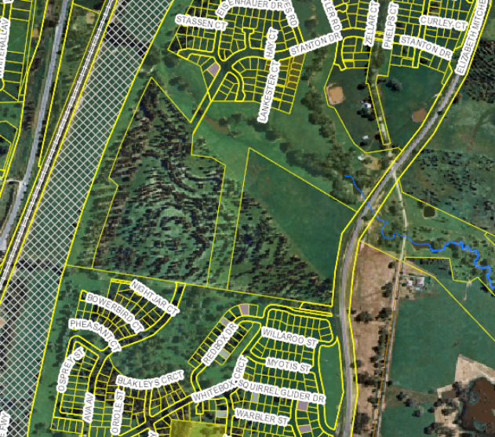

Aerial image - 7 November 2000

1. **STATUTORY CONSIDERATIONS**

When determining a development application, the consent authority must take into consideration the matters outlined in Section 4.15(1) of the *Environmental Planning and Assessment Act 1979* (‘EP&A Act’). These matters as are of relevance to the development application include the following:

1. *the provisions of any environmental planning instrument, proposed instrument, development control plan, planning agreement and the regulations*
2. *the likely impacts of that development, including environmental impacts on both the natural and built environments, and social and economic impacts in the locality,*
3. *the suitability of the site for the development,*
4. *any submissions made in accordance with this Act or the regulations,*
5. *the public interest.*

These matters are further considered below.

It is noted that the proposal is considered to be:

* Integrated Development (s4.46) – Requires consent under the Rural Fires Act 1997. General Terms of Approval issued on 3 March 2023 as per attachment 12.
* Requiring concurrence/referral (s4.13) – Referral to Essential Energy under 2.48 SEPP (Transport and Infrastructure) 2021. Essential Energy general comments provided as per attachment 13.
  1. **Section 4.15(1)(a)(i) - Provisions of Environmental Planning Instruments**

The following Environmental Planning Instruments are relevant to this application:

* *State Environmental Planning Policy (Planning Systems) 2021;*
* *State Environmental Planning Policy (Resilience and Hazards) 2021;*
* *State Environmental Planning Policy (Transport and Infrastructure) 2021;*
* *SEPP (Industry and Employment) 2021*
* *Albury Local Environmental Plan 2010*

A summary of the key matters for consideration arising from these State Environmental Planning Policies are outlined in **Table 3** and considered in more detail below.

**Table 3: Summary of Applicable State Environmental Planning Policies** (Preconditions in **bold**)

|  |  |  |
| --- | --- | --- |
| **EPI** | **Matters for Consideration** | **Comply (Y/N)** |
| SEPP (Planning Systems) | * Part 2.4, Section 2.19 and Schedule 6, Item 5, of the SEPP (Planning Systems) Development for the purposes of an educational establishment that has a capital investment value of more than $5 million. | Y |
| SEPP (Resilience and Hazards) | * Chapter 4 Section 4.6 - Contamination and remediation has been considered in the Statement of Environmental Effects and the proposal is considered satisfactory. See detailed assessment under SEPP below. | Y |
| SEPP (Transport and Infrastructure) | * Division 5, Subdivision 2, Section 2.48 - Development penetrates ground adjacent to underground electricity Referral response from Essential Energy attached. Schedule 2 attached to the draft consent details Essential Energy requirements. * Chapter 3 Education Establishments and childcare facilities. See detailed assessment under SEPP below. | Y |
| SEPP (Industry and Employment) 2021 | * Advertising and signage | Y |

*State Environmental Planning Policy (Planning Systems) 2021*

Pursuant to Part 2.4, Section 2.19 of SEPP Planning Systems, the proposal is a ‘regionally significant’ development as it satisfies the criteria in Schedule 6, Item 5, as the proposal is development for the purposes of an educational establishmentthat has a CIV of more than $5 million. Accordingly, the Southern Regional Planning Panel is the consent authority for the application. The proposal is consistent with this Policy.

***State Environmental Planning Policy (Resilience and Hazards) 2021***

Pursuant to SEPP Resilience and Hazards, Chapter 4, remediation of land requires that in determining development applications, consent authorities are required to consider whether the land is contaminated. If the land is contaminated, authorities are satisfied that the land is suitable in its contaminated state (or will be suitable, after remediation) for the purpose for which the development is proposed to be carried out.

The subject site has been developed for an existing educational facility and has been used for this purpose since 2004. Aerial photography preceding the current use of the site shows the site as vacant with tree planting and an open field in 2000 with no evidence of contaminating activities. There are no uses or activities presently contained within the site, which are potentially contaminating.

The surrounding environmental and residential land also indicates no likely contaminating uses being present. The site is not listed on AlburyCity’s Contaminated Land List or EPA’s Contaminated Land Register. Geotechnical investigations undertaken by Civil Test Pty. Ltd contained in attachment 8 demonstrate the soil profile for the development sites.

The land is considered fit for use for its intended purposes and the proposal complies with the relevant considerations of SEPP Resilience and Hazards.

A site visit was conducted, and whilst there was evidence of site disturbance due to tree removal and prior leveling works, no evidence was present that might suggest the site would be contaminated. The proposal is considered to comply with the relevant land contamination considerations including those under Appendix J of the Albury DCP 2010.

*State Environmental Planning Policy (Transport and Infrastructure) 2021*

SEPP Transport and Infrastructure aims to facilitate the effective delivery of infrastructure across the State by identifying matters to be considered in the assessment of development adjacent to particular types of infrastructure development, and providing for consultation with relevant public authorities about certain development during the assessment process or prior to development commencing. Subdivision 2, Section 2.48 of SEPP Transport and Infrastructure requires development which penetrates the ground within 2m of an underground electricity power line or an electricity distribution pole or within 10m of any part of an electricity tower to be referred to the electricity supply authority and consider response provided.

An underground electricity line runs through the site to the north of the Primary Precinct. The application proposes landscaping/footpath over the existing underground electricity lines, with the junior school building being set back 4.623m from the underground electricity line. The application was referred to Essential Energy with the response contained in attachment 13. General comments provided by Essential Energy are included in the schedule to the Draft Development Consent.

SEPP Transport and Infrastructure, Chapter 3 sets out considerations relating to educational establishments and child-care facilities. The relevant aims of Chapter 3 is to:

* improve regulatory certainty and efficiency through a consistent planning regime for educational establishments and early education and care facilities,
* establishing consistent State-wide assessment requirements and design considerations for educational establishments and early education and care facilities to improve the quality of infrastructure delivered and to minimise impacts on surrounding areas, and
* encouraging proponents of new developments or modified premises and consent authorities to facilitate the joint and shared use of the facilities of educational establishments with the community through appropriate design.

Part 3.4 states development for the purposes of a school may be carried out by any person with development consent on land within the boundaries of an existing school. The application seeks consent for development on land of an existing school.

Clause 3.36(6) of this SEPP states before determining a development application, the consent authority must take into consideration the following matters:

1. *The design quality of the development when evaluated in accordance with the design quality principles set out in Schedule 8 of this SEPP; and*
2. *Whether the development enables the use of school facilities (including recreational facilities) to be shared with the community.*

An Assessment of the design quality principles set out in Schedule 8 of this SEPP is as per below.

|  |  |
| --- | --- |
| **Principles** | **Response** |
| **Principle 1 – Context, built form and landscape**  Schools should be designed to respond to and enhance the positive qualities of their setting, landscape and heritage, including Aboriginal cultural heritage. The design and spatial organisation of buildings and the spaces between them should be informed by site conditions such as topography, orientation and climate.  Landscape should be integrated into the design of school developments to enhance on-site amenity, contribute to the streetscape and mitigate negative impacts on neighbouring sites.  School buildings and their grounds on land that is identified in or under a local environmental plan as a scenic protection area should be designed to recognise and protect the special visual qualities and natural environment of the area, and located and designed to minimise the development’s visual impact on those qualities and that natural environment. | **Complies.**  The proposed buildings are considered appropriately designed and respond to their setting. The proposed buildings seek to rationalise and improve existing facilities and replace a number of transportable buildings onsite.  The applicant has stated that the location of the buildings have been informed by a masterplan which reviewed the future long term growth of the school. Consideration to the spatial organisation of the buildings, such as grouping buildings by age and co-locating shared buildings (music and drama centre) close to the entrance and carpark.  Landscaping is proposed as part of the development and will soften impacts associated with the development.  Cut and fill is proposed across the site to create building pads. Building design and landscape features such as raised undercover areas and benched seating around the multisport courts has been integrated into the design to address changes in typography across the site. |
| **Principle 2 – Sustainable, efficient and durable**  Good design combines positive environmental, social and economic outcomes. Schools and school buildings should be designed to minimise the consumption of energy, water and natural resources and reduce waste and encourage recycling.  Schools should be designed to be durable, resilient and adaptable, enabling them to evolve over time to meet future requirements. | **Complies.**  The school buildings incorporate passive solar design and incorporate large eaves for sun shading. The applicant has stated that energy efficient fittings and fixtures, as well as water efficient fittings will be utilised. |
| **Principle 3 – Accessible and inclusive**  School buildings and their grounds should provide good wayfinding and be welcoming, accessible and inclusive to people with differing needs and capabilities.  **Note—**  Wayfinding refers to information systems that guide people through a physical environment and enhance their understanding and experience of the space.  Schools should actively seek opportunities for their facilities to be shared with the community and cater for activities outside of school hours. | **Complies.**  The school already contains a network of accessible pathways which are at grade and accessible. The areas proposed to be redeveloped incorporate landscaping and footpaths connecting the new buildings and multi-sports courts, bus areas to the existing paths and buildings.  Directional signage is located within the campus which assists in navigation around the site.  The SEE states that community use of several of the existing school facilities including the sports stadium already occurs. It is proposed that community access will be extended to the proposed music and drama centre. |
| **Principle 4 – Health and safety**  Good school development optimises health, safety and security within its boundaries and the surrounding public domain, and balances this with the need to create a welcoming and accessible environment. | **Complies.**  Crime Prevention Through Environmental Design (CPTED) Principles has been considered and pathways are clear, directional signage is available and there are few areas for concealment.  The applicant has noted an existing 2.1 metre high security fence with limited access gates controls ingress and egress points.  The fence integrates with the remainder of the site and the school still presents a welcoming environment through site landscaping, signage and active street frontages with buildings addressing the adjoining Elizabeth Mitchell Drive. |
| **Principle 5 – Amenity**  Schools should provide pleasant and engaging spaces that are accessible for a wide range of educational, informal and community activities, while also considering the amenity of adjacent development and the local neighbourhood.  Schools located near busy roads or near rail corridors should incorporate appropriate noise mitigation measures to ensure a high level of amenity for occupants.  Schools should include appropriate, efficient, stage and age appropriate indoor and outdoor learning and play spaces, access to sunlight, natural ventilation, outlook, visual and acoustic privacy, storage and service areas | **Complies.**  The proposal includes school general learning areas, a multi-sports facility and a music and drama building. The buildings are adaptable and have been designed with the end user in mind in terms of age appropriateness, thermal comfort, acoustics and usability through the location and placement of rooms, provision of supportive facilities and amenities (toilets), storage, and access to sunlight.  No noise mitigation measures are considered to be required. The subject land does not adjoin any rail corridors or highways.  The land adjoins Elizabeth Mitchell Drive, which is a ‘collector road’ however the proposed junior school building is setback 15.864m from the road reserve and is screened by existing roadside vegetation. Further planting is proposed between the building and road reserve and will provide additional screening.  All other buildings are well setback from the adjoining property boundaries, particularly to the south to minimise impacts on adjoining residential neighbours.  The bus bays have been relocated to the south of the site along the existing roadway which will be upgraded. Whilst the location of the bus bays will slightly differ to the existing location, they will remain on the southern side of the site, and their use will generally be limited to pick up and drop off times. No significant additional impact on residential properties to the south is envisaged as the site is separated by Mitchell Park reserve, which contains mature vegetation and an existing local road - Whitebox Circuit. |
| **Principle 6—whole of life, flexible and adaptive**  School design should consider future needs and take a whole-of-life-cycle approach underpinned by site wide strategic and spatial planning. Good design for schools should deliver high environmental performance, ease of adaptation and maximise multi-use facilities. | **Complies.**  The applicant has advised that the proposed works are as per a masterplan that has been recently prepared for the site to ensure the school can grow in an orderly manner.  The new buildings (namely junior and senior building) whilst are purpose-built have the potential to be utilised by other year groups, which provides for flexibility in their use.  The music and drama centre includes both dedicated and a multi-purpose spaces, which will allow for a variety of creative based arts (music, drama and performance) and incorporates operable walls that will allow spaces to be reconfigured depending on the needs of user groups.  The proposed multi-purpose courts could be utilised by a variety of sports and can be utilised to suit the needs of the user via line-marking/ painting. |
| **Principle 7 – Aesthetics**  School buildings and their landscape setting should be aesthetically pleasing by achieving a built form that has good proportions and a balanced composition of elements. Schools should respond to positive elements from the site and surrounding neighbourhood and have a positive impact on the quality and character of a neighbourhood.  The built form should respond to the existing or desired future context, particularly, positive elements from the site and surrounding neighbourhood, and have a positive impact on the quality and sense of identity of the neighbourhood. | **Complies**.  The subject land is located within a mixed use environment consisting of residential, education and environmental land uses.  Whilst a number of trees have already been removed from the site and additional trees are proposed to be removed, a landscape plan has been submitted to enhance the areas proposed for development.  Subject to conditions including additional plantings and appropriate species selection, it is considered the proposed landscaping will assist in enhancing the quality and character of the area, specifically given a predominant characteristic of the area is the environmental corridors which contain a mix of planted and remnant vegetation.  *(B9)* ***Landscaping plan required***  *Prior to issue of a Construction Certificate, a revised landscaping plan is to be submitted to Council for approval. The landscape plan must be generally in accordance with the plan submitted except modified to include the following:*   1. *All retained trees must be identified including tree protection zones (TPZ) and structural root zones (SRZ). The TPZ and SRZ is to be calculated by qualified arborist as per AS 4790-2009 Protection of trees on a development site;* 2. *Include a notation stating:*  * *TPZ’s are to be established prior to commencement of all works (including the removal of identified trees). All retained trees are to have strong, temporary fencing erected around the identified TPZs. This is an exclusion zone for vehicle access and stock piling of building materials. The Project Manager is to ensure that the fencing is maintained, and the exclusion zone is adhered to throughout the construction phase.*  1. *Additional details regarding the garden beds and planting spacing.* 2. *Compensatory planting for the 14 trees proposed to be removed is to include an additional:*  * *a minimum of 15 native trees are to be planted within the proposed development sites of the Senior School & Primary Precinct and Art & Drama Centre.* * *A minimum of 40 local native trees and 200 local native understorey species are to be planted along the boundaries of Trinity Anglican College with emphasis on the eastern and southern boundaries.*   *Please refer to the South-West Slopes Revegetation Guide* [*https://holbrooklandcare.org.au/wp-content/uploads/2020/03/SWSR-guide.pdf*](https://holbrooklandcare.org.au/wp-content/uploads/2020/03/SWSR-guide.pdf) *for appropriate tree and understorey species.*   1. *Updates to the planting schedule as follows:*    * *All planting lists are to be identified by the botanical (i.e. genus, species) and common names.*    * *All proposed and scheduled tree planting locations and the name of the tree species are to be identified. Providing initials of the species of trees is recommended on the graphic representations of trees.*    * *Revise the colour coding system and provide accurate scaling of the vegetation in the landscape plan to assist in accurately interpreting the type of vegetation (ie. distinguishing the shrubs from the trees).*    * *The following proposed tree species are not accepted and are required to be changed as follows:*       + *Euky Dwarf has performed poorly in the Thurgoona area and is to be changed to a medium-sized native species that has performed well in the Thurgoona area. Contact AlburyCity for further information.*      + *Cats Claw Grevillea, although a local native species, does not perform well in a cultivated site and is to be replaced by a hardier grevillea shrub.*   *Once Council has approved the plan it will form a part of this Development Consent.* *(Modified B024)* |

The applicant has stated the following in relation to the shared use of school facilities:

*‘Matters regarding the shared use of school facilities have also been considered in accordance with the requirements of the SEPP. Consistent with the recommendations of this SEPP, the school would seek to allow the use of its facilities (primarily limited to the music and drama or sports stadium) by community groups. It is noted these activities would be limited to outside of normal school hours due to the public safety and liability risks associated with using these facilities whilst the school is operational.’*

*State Environmental Planning Policy (Industry and Employment) 2021*

SEPP Industry and Employment, Chapter 3 Advertising and Signage aims to ensure signage is compatible with the desired amenity and visual character of an area, provides effective communication and is of high quality design and finish. Chapter 3 of the Industry and Employment SEPP is applicable as the proposed signage can be displayed with development consent and is visible from any public place or public reserve.

An assessment of the proposed signage against Schedule 5 Assessment criteria has been undertaken below:

|  |  |
| --- | --- |
| **Criteria** | **Comment** |
| 1. **Character of the area** |  |
| * Is the proposal compatible with the existing or desired future character of the area or locality in which it is proposed to be located? * Is the proposal consistent with a particular theme for outdoor advertising in the area or locality? | The proposed sign is relatively discrete and located on the northern elevation of the proposed music and drama building. The signage will be largely internal facing and has been designed to integrate with the overall appearance of the building and surrounds. No established outdoor advertising them in the area given the surrounding area is generally residential. The sign is similar in theme in terms of the existing onsite signage which is of similar size and colours. |
| 1. **Special areas** |  |
| * Does the proposal detract from the amenity or visual quality of any environmentally sensitive areas, heritage areas, natural or other conservation areas, open space areas, waterways, rural landscapes or residential areas? | The proposed signage will not detract from the amenity or visual quality of the area due to the size of the sign and its general internal facing direction.  The building will be well setback from the adjoining Elizabeth Mitchell Drive and be obscured from views in the public domain. |
| **3**   **Views and vistas** |  |
| * + Does the proposal obscure or compromise important views?   + Does the proposal dominate the skyline and reduce the quality of vistas?   + Does the proposal respect the viewing rights of other advertisers? | The sign will not obscure or compromise any important views, impact on the skyline or impact any other advertisements. |
| **4**   **Streetscape, setting or landscape** |  |
| * + Is the scale, proportion and form of the proposal appropriate for the streetscape, setting or landscape?   + Does the proposal contribute to the visual interest of the streetscape, setting or landscape?   + Does the proposal reduce clutter by rationalising and simplifying existing advertising?   + Does the proposal screen unsightliness?   + Does the proposal protrude above buildings, structures or tree canopies in the area or locality?   + Does the proposal require ongoing vegetation management? | The scale and form of the sign is appropriate in its setting. The sign is proportionate to the building on which is affixed to and will not protrude above the building in any way. |
| **5**   **Site and building** |  |
| * + Is the proposal compatible with the scale, proportion and other characteristics of the site or building, or both, on which the proposed signage is to be located?   + Does the proposal respect important features of the site or building, or both?   + Does the proposal show innovation and imagination in its relationship to the site or building, or both? | The sign is positioned to add interest to a blank part of the building and integrated into the building design. It is compatible with the scale of the building and does not impact on architectural features of the building. |
| **6**   **Associated devices and logos with advertisements and advertising structures** |  |
| * Have any safety devices, platforms, lighting devices or logos been designed as an integral part of the signage or structure on which it is to be displayed? | The sign contains the school logo. |
| **7**   **Illumination** | Not applicable as no illumination proposed. |
| **8**   **Safety** |  |
| * Would the proposal reduce the safety for any public road? * Would the proposal reduce the safety for pedestrians or bicyclists? * Would the proposal reduce the safety for pedestrians, particularly children, by obscuring sightlines from public areas? | The sign is setback from the public road and will not cause any road safety issues.  No impact on pedestrians or bicyclists or sightlines as the sign is affixed to the building and will not protrude. |

*Albury Local Environmental Plan 2010*

The relevant local environmental plan applying to the site is the *Albury Local Environmental Plan 2010* (‘the LEP’). The aims of the LEP include:

*(aa) to protect and promote the use and development of land for arts and cultural activity, including music and other performance arts,*

*(a) to give effect to the desired outcomes, principles and actions contained in the Council’s adopted strategies and policy documents, and*

*(b) to promote sustainable urban development by providing for efficient management of urban growth and resource utilisation, and*

*(c) to promote a city for the people, with a high level of social and physical amenity and a diversity of activities and uses, and*

*(d) to maintain or improve biodiversity across Albury, and to avoid significant impacts on matters of environmental significance*.

The proposal is consistent with these aims as the proposal effects the growth of an educational establishment, through sustainable urban development by providing for efficient management of urban growth and resource utilisation and high level of social and physical amenity within an area of diverse activities and uses.

*General Controls and Development Standards (Part 2, 4, 5, 6 and 7)*

*Zoning and Permissibility (Part 2)*

The site is located within the “General Residential Zone” pursuant to Clause 2.2 of the LEP.

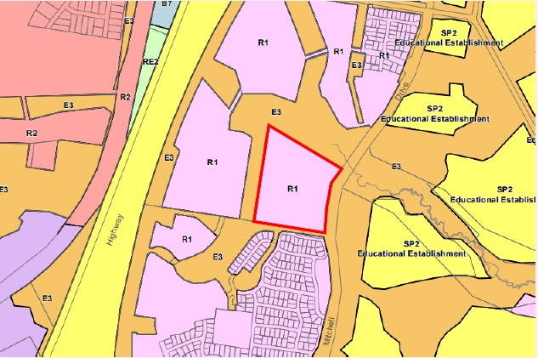 Zoning map extract

SITE

According to the definitions in the LEP Dictionary, the proposal satisfies the definition of ***educational establishment*** which is consistent with the purpose of the zone shown on the Land Zoning Map.

The zone objectives include the following (pursuant to the Land Use Table in Clause 2.3):

* *To provide for the housing needs of the community.*
* *To provide for a variety of housing types and densities.*
* *To enable other land uses that provide facilities or services to meet the day to day needs of residents.*
* *To encourage affordable housing.*
* *To encourage medium density housing that is designed to achieve a high standard of amenity.*

The proposal is considered to be consistent with these zone objectives as it continues to provide an educational facility to meet the day to day needs of residents of AlburyCity. The proposed new school buildings and represents a ‘educational establishment’, which is permitted with development consent in the R1 General Residential zone as it relates to the defined purpose.

Clause 2.7 - Demolition

Clause 2.7 of the LEP states that demolition of a building or work may be carried out only with development consent. This proposal involves demolition works to remove the portable uniform shop and several above ground water tanks, basketball courts, sealed areas and kiss and drop off facility adjacent to the front carpark as identified in the demolition plans as included in the attached plan set. The application details the extent of demolition which is proposed and required to facilitate the redevelopment works for the property.

5.10 Heritage Conservation

The objectives of 5.10 include the following:

*(a)  to conserve the environmental heritage of Albury,*

*(b)  to conserve the heritage significance of heritage items and heritage conservation areas, including associated fabric, settings and views,*

*(c)  to conserve archaeological sites,*

*(d)  to conserve Aboriginal objects and Aboriginal places of heritage significance.*

The site does not contain any heritage items no is it located within a heritage conservation area. The site also does not adjoin any heritage items of land within a heritage conservation area.

The applicant has also considered matters regarding Aboriginal Cultural Heritage and has concluded that no adverse impacts as a result of the proposal, given the development areas have been highly disturbed and are considered to be already improved areas multiple buildings.

The applicant has stated that they have conducted a search of NSW AHIMS database has been undertaken in relation to the existence of any registered cultural heritage items within the site. No items have been identified in the site.

A recommended condition of consent will alert applicant to procedures should any archaeological items be identified during works:

*(A5)* ***Uncovering relics***

*If any archaeological relics are uncovered during the course of the work then works in that area are to immediately cease and the NSW Heritage Office contacted immediately. The applicant is advised that, depending on the possible significance of the relics, an archaeological assessment and an excavation permit under the Heritage Act, 1977 may be required before any further work can be considered in that area of the site. (A705)*

5.21 Flood Planning

The north-west corner of the subject site is identified as being ‘flood prone’ and is subject to certain considerations outlined in this clause.

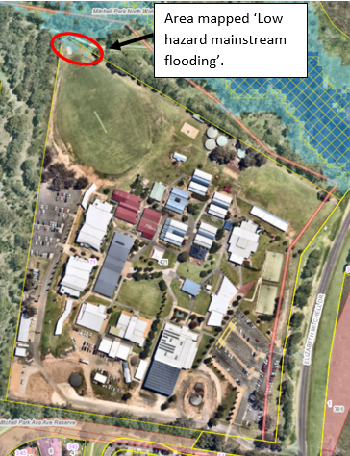

The objectives of this Clause are as follows:

1. *to minimise the flood risk to life and property associated with the use of land,*
2. *to allow development on land that is compatible with the flood function and behaviour on the land, taking into account projected changes as a result of climate change,*
3. *to avoid adverse or cumulative impacts on flood behaviour and the environment,*
4. *to enable the safe occupation and efficient evacuation of people in the event of a flood.*

Under Clause 5.21 development consent must not be granted to development on land the consent authority considers to be within the flood planning area unless the consent authority is satisfied the development—

1. *is compatible with the flood function and behaviour on the land, and*
2. *will not adversely affect flood behaviour in a way that results in detrimental increases in the potential flood affectation of other development or properties, and*
3. *will not adversely affect the safe occupation and efficient evacuation of people or exceed the capacity of existing evacuation routes for the surrounding area in the event of a flood, and*
4. *incorporates appropriate measures to manage risk to life in the event of a flood, and*
5. *will not adversely affect the environment or cause avoidable erosion, siltation, destruction of riparian vegetation or a reduction in the stability of river banks or watercourses.*

Additionally, in deciding whether to grant development consent on land to which this clause applies, the consent authority must consider the following matters—

1. *the impact of the development on projected changes to flood behaviour as a result of climate change,*
2. *the intended design and scale of buildings resulting from the development,*
3. *whether the development incorporates measures to minimise the risk to life and ensure the safe evacuation of people in the event of a flood,*
4. *the potential to modify, relocate or remove buildings resulting from development if the surrounding area is impacted by flooding or coastal erosion.*

The proposed works are located well outside of this area, approximately 280 metres away from the mapped flood hazard.

The works are set back from the adjoining water course to the north and will not adversely impact the environment in terms of avoidable erosion, siltation, destruction of riparian vegetation or a reduction in the stability of riverbanks or water courses.

The proposed development is not considered to have adverse impacts on the flood behaviour, nor is the development considered to have additional cumulative impacts on the surrounding environs as it is located on the flood free portion of the site and appropriate drainage conditions during construction and post construction are recommended on the draft determination.

*(C8)* ***Erosion and Sediment Control***

*Run-off and erosion control measures must be implemented to prevent soil erosion, water pollution or the discharge of loose sediment on surrounding land. The control measures must be in accordance with AlburyCity Council’s adopted Erosion and Sediment Control Guidelines for Building Sites.*

*Erosion and sediment control measures must address and incorporate general site management material handling practices, soil stabilisation, wind erosion, access measures and shall provide for:*

*(a) The diversion of uncontaminated run-off around cleared or disturbed areas*

*(b) The erection of a silt fence to prevent debris escaping into drainage systems or waterways*

*(c) The prevention of tracking of sediment by vehicles onto roads*

*(d) The stockpiling of topsoil, excavated material, construction and landscaping supplies and debris within the site, and the removal or utilisation (where appropriate) of that stockpile after completion of the works.*

*(e) Maintenance of control measures until the land is effectively rehabilitated and stabilised beyond the completion of construction.*

*A copy of the Erosion and Sediment Control Plan must be kept on site at all times during construction and available to Council on request. (Modified C430)*

Clause 7.1 - Earthworks

Clause 7.1 of the LEP relates to earthworks and applies in this instance as the excavation works are not classified as exempt development under *State Environmental Planning Policy (Exempt and Complying Development Codes) 2008*. Proposed earthworks consist of leveling of the development sites. The amended plan and Response to Further Information Letter contained in attachment 4 proposed to include:

* retaining wall in the north-west corner of the multi-sports courts to create tiered seating, as per plans which state the following: ‘*tiered seating 450mm high timber sleeper retaining wall with galvanized H section post and timber sleeper rail. Infill crushed rock landings. Tiered seats to diminish into natural landscape slope’.*
* a retaining wall immediately adjacent to a proposed new storage shed (by others) in the south corner of the property. This area will be used for rubbish storage/collection.
* retaining wall to the south of the junior school precinct.

Consent is required for the earthworks and retaining walls and the provisions of this clause require consideration.

Before development consent can be granted, the following matters must considered:

1. *the likely disruption of, or any detrimental effect on, existing drainage patterns and soil stability in the locality of the development,*
2. *the effect of the development on the likely future use or redevelopment of the land,*
3. *the quality of the fill or the soil to be excavated, or both,*
4. *the effect of the proposed development on the existing and likely amenity of adjoining properties,*
5. *the source of any fill material and the destination of any excavated material,*
6. *the likelihood of disturbing relics,*
7. *the proximity to and potential for adverse impacts on any watercourse, drinking water catchment or environmentally sensitive area.*

The proposed development is consistent with these matters for consideration as follows:

* A concept stormwater drainage plan has been submitted with the application which shows the existing and proposed drainage and the fall of the land. Subject to recommended conditions (detailed above) regarding drainage and sediment and erosion measures, no detrimental impact is expected.
* The proposal will allow for the ongoing use of the site for educational purposes;
* A geotechnical report has been submitted with the application indicating the soil type;
* The proposed earthworks are not expected to adversely affect any adjoining properties as development areas are setback from property boundaries. It is noted that the earthworks associated with the proposed shed applied for under a separate application have already occurred and the retaining walls will not have any significant impact on adjoining lands.
* As outlined in response to Clause 5.10, the subject land is developed and is not expected to contain any relics; and
* The building envelopes setback at least 100m from nearby watercourses to the north. Appropriate drainage conditions and erosion and sediment control conditions during construction will ensure water quality in the area is not impacted.

Clause 7.6 – Essential Services

Clause 7.6 of the LEP refers to essential services and aims to ensure that all relevant services are available to the site. Development consent must not be granted to development unless the consent authority is satisfied that any of the following services that are essential for the proposed development are available or that adequate arrangements have been made to make them available when required:

* 1. *the supply of water,*
  2. *the supply of electricity,*
  3. *the disposal and management of sewage,*
  4. *stormwater drainage or on-site conservation,*
  5. *suitable road access.*

As noted above, the site is within an established urban area of Thurgoona with existing suitable access and connection to reticulated water, sewer and electricity infrastructure, urban stormwater drainage and public road access. Internal services may be realigned and connected where necessary within the Lot boundaries. In consultation with the applicable service providers, all services are confirmed to have suitable capacity for minor augmentation work as required.

* 1. **Section 4.15 (1)(a)(ii) - Provisions of any Proposed Instruments**

There are no proposed instruments which have been the subject of public consultation under the EP&A Act, which may be relevant to the proposal.

* 1. **Section 4.15(1)(a)(iii) - Provisions of any Development Control Plan**

The following Development Control Plan is relevant to this application:

The Albury Development Control Plan 2010 (“the DCP”) provides specific a guideline for development within the Albury City Local Government Area, including the subject site. Section 4.15(3A) of the EP&A Act requires a consent authority to apply its DCP provisions flexibly and allow reasonable alternative solutions that achieve the objects of those standards.

The following chapters of the DCP are applicable to the proposed development:

* Part 3 - Development Notification Policy
* Part 4 – Developer Contributions
* Part 5 – Vegetation Protection
* Part 6 – Planning for Hazards
* Part 10 – Development in the Residential Zones
* Part 16 – Outdoor Advertising
* Part 17 – Off-street parking

The below details provide an overview of consistency and compliance of the proposal against the relevant chapters of the DCP.

Part 3 – Development Notification Policy

Development notification provisions are as per the AlburyCity Community Participation Plan 2020. A development application which includes integrated development is required to be advertised for a minimum of 30 days. The application was advertised from 22 October 2022 to 21 November 2022. One submission was received which is addressed later in the report.

Part 4 – Developer Contributions

Part 4 of the DCP provides details regarding the payment of developer contributions under Section 7.11 or 7.12 of the *Environmental Planning and Assessment Act* and/or Section 64 of the *Local Government Act 1993*, to provide Council with funds to provide coordinated infrastructure and services for the City. Developer Contributions will be levied in accordance with the requirements of the *Albury Infrastructure Contributions Plan 2014* (ICP).

The subject land is located within a Section 7.11 (formally Section 94) area.

Section 1.2.1 of the ICP sets out the circumstances in which Section 7.11 contributions are applicable. Section 7.11 contributions are only applicable to residential accommodation (dwellings or per lots) and are not applicable to educational establishments as per Table 1.1 of the ICP.

As a result, no Section 7.11 Developer Contributions are proposed to be levied against the proposal.

The site is located within a Section 64 Water and Sewer contributions area.

As per the Water Directorate Guidelines 2017, the development is defined as Education – School (primary &secondary) and the standard unit of measure is per person. Page 27 of the SEE states that an additional 263 students and 9 staff totalling an additional 272 persons.

Section 64 Water and Sewer Contributions have calculated based on the additional persons in accordance with Water Directorate and conditions have been included in the Draft Determination:

*(1)* ***Infrastructure Contributions (Section 64)***

*The following monetary contributions are required and payable to Council in accordance with Section 64 of the Local Government Act, 1993, to provide for the increased demand for public amenities and services resulting from the development.*

|  |  |  |
| --- | --- | --- |
| ***Purpose*** | ***Hot key*** | ***Total*** |
| *Section 64 - Water* | *227* | *$27,980.64* |
| *Section 64 - Sewer* | *228* | *$62,179.20* |
|  |  | ***$90,159.84*** |

*The amounts payable under this condition are due prior to the release of the Construction Certificate and will be indexed annually in accordance with Clause 3.17 of the City of Albury Infrastructure Contributions Plan 2014. Prior to payment of the above contributions, the applicant is advised to contact Council to verify the amounts due and payable. It is the responsibility of the Principal Certifying Authority to ensure that contributions have been paid to Council in accordance with this Consent.*

*This contribution has been imposed in accordance with City of Albury Infrastructure Contributions Plan 2014. Council’s Contributions Plan can be viewed at* [*www.alburycity.nsw.gov.au/*](http://www.alburycity.nsw.gov.au/) *or a copy may be inspected or purchased at Council’s Administration Centre. (B304)*

Part 5 - Vegetation Protection

Part 5 of the DCP guides the management and preservation of trees, vegetation, and native vegetation across the Albury LGA. Relevant objectives include: to maintain and improve Albury’s total vegetation and urban canopy cover Protect vegetation, minimise soil erosion or sedimentation into waterways and to recognise the values of large old trees in the landscape. In the instance of this development, permission is required for the removal of trees three (3) metres or more in height and with a trunk circumference of 300mm or more at 1.3 metres above ground level.

The development requires approval for the removal of 14 trees.

It is noted that approximately 30 trees have recently been removed on-site without any approval. As retrospective permission cannot be applied, this matter is being dealt with separately by Council and therefore does not form part of part of the approval. As a result, there are some discrepancies within the SEE in relation to what is proposed to be removed as the Section which refers to Part 5 of the DCP has not been updated in the SEE. A separate cover letter for tree removal, and a tree removal plan which includes locations and a schedule with tree species, diameters etc. has been submitted for assessment and is included in attachment 5.

A Test of Significance (ToS) by Hamilton Environmental Services (Steve Hamilton) was also submitted with the application and is included in attachment 9. The ToS was undertaken prior to much of the tree removal which has already occurred onsite, however provides reference to vegetation management and landscaping which should be adopted, given the surrounding environmental corridors. The report states by taking a conservation approach, the assessed area provides opportunities for seasonal foraging/hunting for all eighteen threatened species of fauna likely to be found within the area. The guiding conservation principle for this development site, which is surrounded by environmental lands, should be to protect and enhance the environmental assets. Council officer’s suggest the overall goal for this development is no net loss of canopy cover or biodiversity.

To compensate for the loss of vegetation on-site proposed by the application, (14 trees) the school proposes to undertake extensive landscape plantings in accordance with the recommendations provided in the proposed landscaping plan.

Following an assessment by Council’s Environmental Planners and Urban Forest Officer, a condition (detailed above) on the Draft Determination has been recommended to require revised landscape plans to be submitted to include tree protection zones for all existing trees, clarification on planting schedule and additional compensatory plantings. Subject to compliance with the condition, it is considered that the application will achieve the guiding principle of no net loss canopy cover or biodiversity and will appropriately contribute to the natural character of the area.

Part 6 – Planning for Hazards

Part 6 of the DCP seeks to minimise the risks associated with natural hazards, including bushfire, flooding and land contamination. The subject site is not known to be contaminated.

A small portion of land in the north-western corner which is not within the development area is identified as a Flood Planning Area (Low Hazard Mainstream Flooding). Given the development is located approximately 280m from the mapped area, no impacts are envisaged and further assessment under Part 6 is not required.

Portions of the subject land are identified as bushfire prone land, including ‘Vegetation Buffer’ and a small portion along the southern boundary to the east of ‘Vegetation 1’ on the Albury Bushfire Prone Land Map as per below:

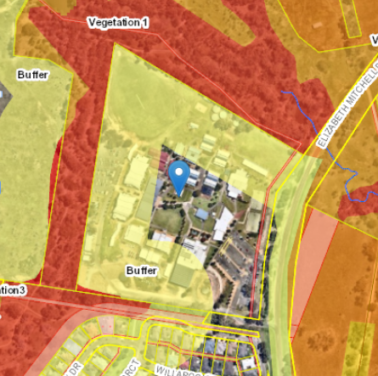

The area of land, identified by the red overlay, represents a 100m wide bushfire buffer zone that extends buffers the Category 1 and 2 Vegetation to the north, west and part of the south of the site.

Section 6.4 of the DCP refers to bushfire. The objectives of Section 6.2.1 are:

1. To ensure, where consent is required for subdivision and development, that the following occurs in bushfire prone areas:

* Occupants of any building are afforded with adequate protection from exposure to a bushfire.
* A defendable space is located around buildings.
* Appropriate separation between a hazard and buildings which, in combination with other measures, prevent direct flame contact and material ignition.
* Safe operational access and egress for emergency service personnel and residents is available.
* Ongoing management and maintenance of bushfire protection.
* Measures, including fuel loads in the Asset Protection Zone (APZ), are established.
* Utility services are adequate to meet the needs of fire fighters (and others assisting in bushfire fighting).

The proposed development is consistent with the objectives of Section 6.4 as the development will be set back from the adjoining bushfire hazards (Category 1 and 2 Vegetation) and maintain the required Asset Protection Zone (APZ). The 35 m wide APZ is proposed to be located entirely within the site and will not impact adjoining C3 – Environmental Management zoned land. The proposed buildings are separated from the hazard source by sealed driveways and carparking areas. The site is connected to a reticulated water supply. A Bushfire Risk Assessment has also been prepared in support of the proposed application and the application (included in attachment 10) was submitted to the NSW Rural Fire Service (RFS) as ‘integrated development’, requiring a Bush Fire Safety Authority (BSA), under section 100B of the Rural Fires Act 1997. General Terms of Approval was issued by RFS on 3 March 2023 and attached to this report. The conditions of the General Terms of Approval have been included in the schedule of the Draft Determination.

Overall, the proposed development is consistent with the applicable objectives and controls of Part 6 of the DCP.

Part 10 – Development in Residential Zones

Division H – Non-residential development in Residential Zones.

*i. Objectives*

*Objectives for development to which Division H applies are to be considered by Council when a development application is determined. The objectives are, to:*

*a. Ensure non-residential development permitted in residential zones responds to the environmental conditions of the site and the locality.*

*b. Enable non-residential development permitted in residential zones to be compatible with the streetscape and to contribute positively to the character of the locality in which development is proposed.*

*c. Create reasonable amenity for occupants of non-residential development permitted in residential zones without causing unreasonable impacts on the amenity of neighbours*

**Development Guidelines Table A**

| **Division H cl. 2 Non-residential development in residential zones** | | |  |
| --- | --- | --- | --- |
| **Design elements** | **Guidelines** | **Performance criteria** |  |
| 1. **Site planning.** | | | **Response** |
| 1. Min. landscaped area.   Min. width of landscaped areas (to count as part of min. landscaped area).  Min. proportion of the primary street setback to be landscaped area.  Refer to Figure 13 in the Schedule. | 30% of lot area.  1m.  25%.  Erection of ancillary development is not to reduce the min. landscaped area to an amount less than that required for the lot. | Adequate landscaped area is provided, to ensure:   * Space for growing plants, including trees, * Absorption of rainwater into the ground, * Reasonable amenity for residents, * Lots are not over-developed with buildings, structures and paving, and * Paving and buildings do not dominate the streetscape. | **Complies.**  At least 30% of the lot area is ‘landscaped area’. |
| 1. Development on a battle-axe lot. | Development guided by this clause is not favoured on a battle-axe lot, unless:   1. The lot adjoins or has an outlook to public open space or another type of public reserve, or land in an environmental protection zone, and, 2. Access to the lot is suitable for the development. | Development on a battle-axe lot:   1. Provides reasonable amenity for occupants and neighbours, 2. Is compatible with the public domain and the character of the locality, 3. Addresses public open space or another type of public reserve, or land in an environmental protection zone, and 4. Is provided suitable access. | **Not applicable.** |
| 1. Max. basement area. | Within applicable building setbacks. | Basements do not impact the ability to maintain or plant vegetation on the lot. | **Not applicable.** |
| 1. **Building height.** | | |  |
| 1. Max. no. of storeys, | 2.  Does not apply in R3 and B4 zones. | The number of storeys is compatible with the streetscape and the character of the locality.  The number of storeys reasonably maintains acceptable relationships with adjoining development, in terms of bulk and scale and resident-amenity. | **Complies.**  The buildings are not proposed to be higher than two storeys. |
| 1. Max. no. of storeys in the rear 40% of a lot, measured as a percentage of the average length of the two side boundaries. | 1.  Does not apply in the R3 and B4 zones (except when the lot adjoins land in the R1 or R2 zones), or when the lot adjoins a rear lane, or is a corner lot, or is in a heritage conservation area. | Development in the rear of a lot maintains resident amenity and is compatible with local character. | **Variation proposed.**  Given the significant building setbacks and Environmental lands which provide a buffer between the site and residential uses, the proposal does not impact on residential amenity and is compatible with local character. |
| 1. Earthworks, retaining walls & related structures.   Refer to Figures 14 & 15 in the Schedule. | Development is to be stepped to align as closely as possible with the slope of the lot.  Earthworks and related structures are not to result in finished ground levels that differ by more than 600mm from existing ground levels at any boundary with adjoining land.  If the lot was benched when the land was subdivided, earthworks and related structures are not to further increase or decrease finished ground levels at any boundary with adjoining land.  All earthworks and related structures are to be properly drained and not direct surface water onto adjoining land. | Adverse impacts of earthworks and related structures on adjoining land, resident-amenity, streetscape and the character of the locality are avoided, or acceptably minimised or mitigated. | **Complies.**  Earthworks and retaining walls are proposed, however are setback from property boundaries and will not have significant impact on adjoining lands. |
| Structures related to earthworks that differ by more than 600mm from existing ground levels, including any retaining, drainage works or other works, are to be designed by a suitably qualified and experienced engineer. | Earthworks and related structures and infrastructure are properly designed. | **Complies** via condition contained on Draft Determination (B5). |
| Appropriate construction techniques, including minimising removal of vegetation where possible, are to be implemented to assist in erosion and sediment control during and post construction.  An erosion and sediment control plan is to be submitted with a development application, except when development does not involve soil disturbance or when soil disturbance is insignificant. | Construction of earthworks and related structures does not adversely impact stormwater flows and the environment. | **Complies** via condition contained on Draft Determination (B5). |
| 1. **Setbacks.** | | |  |
| 1. Min. primary street setback.   Refer to Figure 16 in the Schedule. | Average setback of the two buildings closest to the lot, in the same street and on the same side of the street.  4m when averaging as set out above is impractical. | Setbacks are compatible with the setback of neighbouring buildings.  Setbacks contribute to a consistent streetscape and character in the locality. | **Complies.**  The junior school (K-2) building is proposed to be set back 15.843m from Elizabeth Mitchell Drive road reserve.  The closest adjoining dwellings are to the south of the site and are accessed off White Box Circuit which runs alongside Elizabeth Mitchell Drive.  Therefore averaging is considered impractical. The 15m setback is appropriate given the context of the site and surrounding area. |
| 1. Min. secondary street setback on a corner lot. | 50% of the primary road setback. | **Not applicable.** |
| 1. Min. side setback. | 0.9m, when building height closest to the boundary does not exceed 4.5m.  1.5m, when building height closest to the boundary exceeds 4.5m.  Side setbacks may be less than specified above, to boundaries of a lot that adjoins land in a Business or an Industrial zone. | Adequate building separation is provided at side boundaries, for amenity, boundary fencing, access, safety, and maintenance. | **Complies.** |
| 1. Min. rear setback. | 3m, when building height closest to the boundary does not exceed 4.5m.  6m, when building height closest to the boundary exceeds 4.5m. | Adequate building separation is provided at rear boundaries, for access, safety, privacy and sunlight access. | **Complies.** |
| 1. Min. garage setback from a rear lane. | 0m, provided there is adequate area for access into and egress from a garage.  Entry to and exit from a garage is to be demonstrated by plans of swept paths of vehicles, if required. | Safe and practical entry to and exit from a garage off a rear lane is provided. | **Not applicable.** |
| 1. Exceptions to the primary street setback. | In areas undergoing change in their character due to various circumstances (e.g. a change in zoning or land economics), a site and context analysis is to be carried out to establish an appropriate setback to the street, when an exception is sought to the primary street setback.  Applicants are to consult with Council regarding the appropriate application of this guideline when preparing a development application. | The primary street setback is established in accordance with a site and context analysis, that has considered the area’s character and specific circumstances related to the site and its development. | **Not applicable.** |
| 1. Other exceptions to setbacks. | 450mm is the minimum side or rear setback for any aerial, antenna, awning, eave, flue, chimney, pipe, cooling or heating appliance, any rainwater tank greater than 1.8m in height, or any other structure, installation or appliance associated with the provision of a utility service.  Side or rear setbacks do not apply to fences, fascias, gutters, downpipes, light fittings, electricity or gas meters, driveways, open carports, paths or paving.  Setbacks from streets and lanes do not apply to driveways, fences, paths, or retaining walls. | Services and utilities are able to be located within side and rear setbacks, without unreasonable adverse impacts on neighbours’ amenity.  Enables siting of ancillary works that must be located on, over or between lot boundaries and buildings. | **Not applicable.** |
| 1. **Character & the public domain.** | | |  |
| 1. Character. | The building is designed to be compatible with the streetscape and character of the locality. | Development is of high architectural quality and contributes positively to local character and a safe public domain.  Design and choice of materials and colours are compatible with surrounding development and contribute to a pleasant and attractive public domain.  The mass and form of development integrates with and promotes diversity in the locality through quality urban design. | **Complies.**  The buildings are two storeys in height and will create visual interest and contribute to the character of the area.  Materials and colours are considered appropriate and reflect the school colours/branding.  The proposed works are separated from adjoining residential uses. Landscaping has been incorporated in the design which will contribute to the providing an attractive public domain. |
| 1. Design, massing & articulation.   Refer to Figure 17 in the Schedule. | Massing and articulation are to reduce apparent scale and bulk and create visually interesting buildings.  Materials, textures and colours are to complement the massing and design of the building.  Buildings are to be suitably articulated using harmonious architectural elements in the design, such as verandahs, porticos, awnings, bay windows, balconies or terraces. Elements such as these may be forward of the primary street setback.  Simple roof forms are to be designed to complement other building elements and minimise bulk and scale of the building. Roof forms are to be compatible with those of nearby buildings.  Infrastructure and services are to be integrated into to the development’s design or screened. | **Complies.**  The buildings are modern and architecturally designed and include articulation and fenestration through the use of openings, windows, covered awnings and porticos and varying materials and finishes.  The buildings have been designed with skillion roofs to reduce building bulk and height. |
| 1. Community safety & surveillance. | Principal pedestrian entries are to address, be readily identifiable and directly accessible from the street.  Principal pedestrian entries are not to be from a lane.  When a building façade faces a reserve or other element of the public domain, that façade is to include windows and/or doors to address that reserve or other element of the public domain.  Fencing and landscaping are not to unacceptably diminish informal surveillance of the public domain. | A safe method of access to and egress from development is provided.  Development contributes to community safety and informal surveillance of the public domain. | **Complies.**  Pedestrian access is existing to the residential estate to the south and includes a pedestrian crossing  The building entries will be identifiable and address the internal pathway network.  Areas will be open, well-lit and the design of the buildings is such that passive surveillance opportunities are maximised.  Landscaping works are incorporated into the design and are not considered diminish informal surveillance into the site. Security fencing already exists on-site and will ensure site security. |
| 1. Signage. | Relevant provisions of SEPP 64 are adopted for design guidance of advertising structures and signs. | Signage is properly designed. | Complies as per assessed under SEPP 64 and Part 16 of DCP. |
| 1. **Occupant & neighbour-amenity.** | | |  |
| 1. Sunlight access.   Refer to Figures 19 & 20 in the Schedule. | Windows and doors of habitable rooms and open space areas, if provided for occupants or visitors of the development, are to be sited and oriented to receive at least 3 hours direct sunlight between 9am and 3pm on the winter solstice. | Sunlight access to primary indoor areas and open space is optimised.  Sunlight access enables passive solar heating in winter and provides a pleasant and healthy indoor environment. | **Not applicable.**  No habitable rooms proposed. |
| 1. Overshadowing. | Proposed development must retain at least 3 hours of sunlight between 9am and 3pm on the winter solstice for existing neighbouring residential accommodation’s:   * Windows and doors of habitable rooms except bedrooms, * At least 50% of private open space, * Photovoltaic and solar hot water systems, and * Outdoor clothes drying facilities.   If areas or utilities specified in the above paragraph of existing neighbouring residential accommodation receive less than 3 hours sunlight at the time a development application is lodged for adjoining land, the amount of sunlight received is not be reduced as a result of proposed development.  When existing neighbouring residential accommodation may have its sunlight access impacted by proposed development, a shadow diagram is to be submitted with the application for the proposed development, based on the winter solstice, in hourly intervals from 9am to 3pm. | Sunlight access to existing neighbouring residential accommodation is reasonably maintained. | **Complies.**  The new buildings are well setback from adjoining neighbours and will retain existing solar access. |
| 1. Climate management for west-facing buildings.   Refer to Figure 18 in the Schedule. | Where habitable rooms face west (between north-west and south-west), architectural elements are to be used, such as:   * Extended eaves, * Verandahs, * External shutters or louvres, or * Awnings.   Architectural design elements can be complemented by landscaping. | Heat-gain is reduced to improve thermal performance and comfort for occupants of non-residential development. | **Not applicable.** |
| 1. Privacy.   Refer to Figure 23 in the Schedule. | When privacy of occupants of proposed development or neighbours is likely to be affected, siting and design of the proposed development is to maintain reasonable levels of privacy.  Principal siting and design techniques to consider and use, include:   * Building orientation, * Position of habitable rooms, * Window size and location, * Building separation and setbacks, * Avoiding or minimising direct lines of sight, and * Location of balconies and terraces adjacent indoor living areas.   When principal techniques may not maintain reasonable levels of privacy, supplementary techniques to consider and use include:   * Recessed balconies or vertical fins, * Solid or partially solid balustrades, * Bay or pop-out windows, * Planter boxes, * Privacy screens, * Sill heights, or * Opaque window glazing. | Privacy between residents of proposed development and neighbours is reasonably protected. | **Complies.**  The development does not cater for any private residents and the school buildings are well setback from adjoining residential neighbours so as to avoid overlooking or privacy concerns. |
| 1. Landscape design. | A landscape concept plan is to be provided, prepared in accordance with Council’s *Engineering Guidelines Subdivisions and Development Standards.* | Landscape planning and design is properly conducted for development. | **Complies** subject to conditions.  A landscape plan has prepared and submitted with the application. Draft condition B9 requires the provision of a revised landscaping plan. |
| 1. Safer by design. | Development applications for the following developments are to be accompanied by a safer by design (crime prevention through environmental design) assessment:   * Childcare centres, * Community facilities, * Educational establishments, * Health services facilities, * Places of public worship, and * Serviced apartments. | The risk of anti-social behaviour, criminal activity and reduced public safety is avoided, minimised or mitigated.  Development is liveable and safe for its occupants. | **Complies**  Crime Prevention Through Environmental Design (CPTED) assessment has been undertaken in the submitted SEE to inform the outcomes of the design. |
| 1. Hours of operation. | Hours of operation will be considered with regard to the site’s location, access to the road network and potential to impact amenity of residents in the locality. | Hours of operation are appropriately established depending on site and contextual circumstances. | **Complies.**  Normal school day: Monday to Friday – 8:00am to 4:00pm  Out of hours operations (performances, parent teacher interviews etc) – on an as needs basis. |
| 1. Noise & air quality. | When there is a risk development will be impacted by a nearby source of noise or offensive or hazardous emissions to the atmosphere, the development is to be designed and sited to acceptably reduce that risk.  When deemed necessary by Council, a noise and/or air quality impact assessment is to be submitted with a development application and the development’s design is to adopt the recommendations of that assessment. | Impacts of noise and air-emissions are avoided or effectively mitigated and minimised. | **Complies.**  No significant unreasonable noise, or reduced air quality as a result of the proposal.  Construction noise and dust control conditions included in Draft Determination (D1, D4).  Similarly, the proposed use will not be adversely affected by existing noise sources. |
| 1. Waste Management. | Provide bin storage in accordance with Council’s kerbside requirements, in a readily accessible location for residents.  Bins are not to be stored forward of the primary street setback, or in a location visible from the public domain.  Construction and demolition waste is to be managed and disposed of in accordance with the requirements of Council or another authority, when applicable. | Waste storage meets residents’ requirements, reasonably maintains resident-amenity and the qualities of the streetscape and the character of the locality.  Waste from the development is effectively managed in accordance with applicable requirements. | Complies.  Currently waste storage occurs in the location of the Senior building. As a result of the proposal, the waste storage and collection area will be relocated to be adjacent to the proposed shed (by others) to the west of the site. The proposed retaining wall will assist in providing screening to the area. Given it is located to the rear of the site, no impact will be caused to the streetscape of character of the area as a result of the revised waste storage location. |
| 1. Building materials. | Reflective building materials are not to be used. | Building materials do not unreasonably diminish neighbours’ amenity. | **Complies.**  A range of building materials and finishes are proposed, none of which will be reflective. |
| 1. **Boundary treatments (fences & walls).** | | | **Not applicable** |
| 1. **Access & parking.** | | |  |
| 1. Pedestrian access. | Pedestrian entries are to be clearly identifiable and visible from the street.  Entries are to provide direct access to letter boxes.  Entries and paths from the street are to be suitably lit at night. | Pedestrian entries to development are safe and provide amenity for and informal surveillance of the street. | **Complies.**  No new pedestrian entries from the street are proposed as part of the application. Existing pedestrian entries will be maintained and internal footpaths will be suitably lit and provide access to the entries of the proposed new buildings. |
| 1. Min. no parking spaces. | Specified by Part 17. | The number of on-site parking spaces is adequate and acceptably impacts parking supply on local streets. | **Complies.**  See assessment under Part 17 of DCP. |
| 1. Internal access design.   Refer to Figure 25 in the Schedule. | Internal access design is to consider and be based on a combination of these principles:   * Avoid unrelieved, long, straight driveways that are visually dominant. * Vary the alignment of driveways to avoid a ‘gun-barrel’ effect’. * Set back parking areas and garages behind the predominant primary street setback to reduce their visibility from the street * Avoid driveways running the length of the site. * Minimise the impact of driveways on streetscape. * Terminating vistas with trees, vegetation, open space or a building, not garages or parking. * Use planting to soften driveway edges * Varying the driveway surface material to break it up into series of smaller spaces. * Limiting driveway widths on narrow sites to single vehicle width with passing bays when required. | Internal access design is safe, functional, visually appealing and contributes positively to the streetscape. | **Complies.**  Internal access is already established. The application will formalise internal access arrangements and shift the bus bay area which provides a better internal traffic management outcome than the existing arrangement. |
| 1. **Utility infrastructure.** | | |  |
| 1. Access to the development and associated road works. |  | Access to the development and associated road works are consistent with Council’s Engineering Guidelines for Subdivisions and Development Standards.  On bush fire prone land, access is provided in accordance with RFS guidelines. | **Complies.**  No change to the proposed access arrangements to and from the site. |
| 1. Water and sewer supply. |  | If required, arrangements are made with Council, the water and sewer authority, for provision of water and sewer services.  Such arrangements are consistent with Council’s Engineering Guidelines for Subdivisions and Development Standards.  On bush fire prone land, water supply is provided in accordance with RFS guidelines. | **Complies.**  Reticulated water and sewer is already connected to the site. |
| 1. Stormwater management. | A stormwater management concept plan is to be submitted with a development application. | Stormwater management is consistent with Council’s Engineering Guidelines for Subdivisions and Development Standards. | **Complies.**  A stormwater concept plan has been submitted with the application. |
| 1. Electricity, gas and telecommunications services. |  | Evidence is provided to Council, that these services are available, before issue of an occupation certificate. | **Complies.**  The site is established and connections to essential services are existing. |
| 1. **Master plans & concept development applications.** | | | **Not applicable.** |

Part 16 – Advertising Signage

Chapter 16 of the DCP relates to Advertising signage and sets the requirements for advertising signage including design, visual impact and public safety requirements.

The one proposed flush wall business identification signs is not proposed to be illuminated and will contain the school logo painted in the school colours (red, white and blue). The proposed sign is consistent with Part 16 as it will display a clear, well communicated message, reinforcing the sense of place of the education establishment. The proposed sign will not create any negative visual impacts given it is flush with the wall and will integrate into the architectural building form. The scale of the sign is appropriate with respect to the size of the buildings in which it is affixed to. Given the building is setback from property boundaries, no significant impacts on public domain are envisaged, including on road safety.

The sign is not considered to be of a signage type which is not permitted as set out in Part 16.5 of the DCP. Whilst Part 16.5 xvii. states ‘Signs of a height greater than 1.8 metres within residential zones’ will not be permitted, the intent of this control is relation to pole mounted signs, not flush wall signs affixed to a building. This control has been consistently applied in this manner throughout AlburyCity.

Part 17 – Off-street parking

Chapter 17 of the DCP relates to car parking, and sets the parking requirements for various land uses, as well as other design related requirements for the operation and embellishment of car parking.

The proposed development increases the capacity of the school and therefore increases the demand on car parking within the site. For the purposes of calculating car parking for an educational establishment, the DCP requires the following:

* 1. *preschools, infants and primary school require a carparking rate of 1 per staff member*
  2. *secondary schools and tertiary institutions require a carparking rate of 1 per staff member plus 1 per 10 Year 12 students.*

Staff parking:

The development proposes an additional nine (9) staff, an increase from 103 staff to 112 staff members. The amount of existing staff car spaces required is 103 spaces (based on an existing 103 staff). The amount of additional staff car spaces required is 9 spaces (based on an increase of 9 staff).

**The total amount of staff car spaces for the site is 112.**

Student parking:

The development proposes an additional 263 students, an increase from 1,301 to 1,574 students. The TIA states that the total number of proposed year 12 students is not known and provides the following rationale behind carparking figures for year 12 students.

*‘Information provided by the College suggests that 1,198 students (including 88 year 12 students) are currently enrolled, and 64 full time staff and 103 part time staff are currently employed.*

*Considering an increase in total students of approximately 20%, this rate can be applied to the 88 existing year 12 students, producing an estimated 106 students. 110 students will be adopted for conservative measures.’*

Council Officers consider the above rationale acceptable in terms of calculating the required amount of car parking spaces for year 12 students.

The amount of existing student car spaces required is 9 spaces (based on an existing 88 students). The amount of student car spaces required as a result of the increase in students is 2 spaces (based on 20% of 88 totalling 17.6 students).

**The total amount of student car spaces for the site is 11 spaces.**

The total number of carparks required by ADCP based on existing and proposed staff andstudents is **123 car spaces.**

The SEE states that the current carparking allows for a total of 224 car spaces. However, the plans submitted and the TIA state 227 car parks are existing onsite. A count of the sealed, line marked spaces was undertaken by Council Officers and it was found that only 213 spaces are located on site.

Clarification was sought from the applicant, and it was confirmed the discrepancy is as a result of recent works undertaken to rationalise the front carpark to allow for a drop off area and provide one way traffic flow through the carpark.

The number of formalised onsite carparking at 213 spaces is well above the required carparking rate set by DCP of 123 car paces and therefore is considered acceptable and no additional spaces are required as a result of the proposed development.

While modification as not proposed to car parking associated with the proposed development, a condition on the draft determination is proposed to require all on-site car parking to be in accordance with AS2890.1 and AS2890.6 (draft condition A7).

The TIA also recommended that localised shoulder widening be provided similar to that of a BAL treatment (basic left turn) to allow for the existing volume of left turning motorists into the site from the south. Council Officer’s support the recommendation and a condition is recommended for a BAL to be constructed to main entrance (southern), adhering to relevant standards and be approved by Council. The BAL must also be designed for 70kmph approach speed.

The following conclusions have also been included in the TIA:

* *The access layouts have been designed generally in accordance with the requirements of the Albury DCP 2010 and the Australian Standards and are considered appropriate;*
* *The retention of the existing pedestrian crossing is considered appropriate;*
* *The design of the bus turnaround and pick-up/drop-off areas are considered appropriate and will result in an improvement on the existing traffic arrangements;*
* *The existing kiss and drop facilities will continue to operate under good conditions;*
* *The provision of car parking exceeds the parking requirements for the site, even after the removal of the informal parking area;*
* *Existing traffic generation at the college has a significant bias to the south (90%);*
* *Based on the increase in students, additional traffic will be generated to the road network;*
* *The level of traffic generated is not expected to result in a noticeable impact to existing operation; and*
* *Whilst there will be no noticeable impact to the operation of the road network, it is recommended that a basic left turn treatment (BAL) at the southern site access is provided to improve existing movements into the college and to allow for the free flow of northbound traffic.*

Pedestrian priority is to be given where any path crosses an access road. All new paths should be designed to be Disability Discrimination Act compliant.

In relation to bicycle and motorcycle parking, Part 17.3.3 requires bicycle parking to be provided at a rate of 1 bicycle rack for each 10 spaces and 1 motorcycle space per 30 car parks. Based on 123 car parks, a minimum of 12 bicycle spaces is required and 4.1 motorcycle spaces are required. Whilst no designated motorcycle spaces are provided, given the excess parking onsite, motorcycles are able to use existing car parks.

The submitted landscape plans show bicycle racks for 30 bikes located adjacent to the bus bays which are also in close proximity to the existing change rooms which are proposed to be used as ‘end of trip facilities’. Safety concerns have been raised in relation to the location of the bicycle parking being adjacent to the bus zone. A condition is recommended on the draft determination for bicycle parking to be separated from the bus zone to reduce conflict opportunities be between people riding, people getting on and of the buses, and between people riding and the bus movements. Bicycle parking will also required to be undercover to protect parked bicycles from the weather – sun and rain and racks are to be provided to ensure there is the ability to securely lock up a bicycle. “Toaster” style racks are not appropriate. A draft condition of consent will require details of proposed bicycle parking type to be provided and approved (draft condition B7).

* 1. **Section 4.15(1)(a)(iiia) – Planning agreements under Section 7.4 of the EP&A Act**

There have been no planning agreements entered into and there are no draft planning agreements being proposed for the site.

* 1. **Section 4.15(1)(a)(iv) - Provisions of Regulations**

Clause 92(1) of the Regulation contains matters that must be taken into consideration by a consent authority in determining a development application, comprising the following:

* *If demolition of a building proposed - provisions of AS 2601;*

These provisions have been considered and addressed in the draft conditions C1 and C2 (where necessary).

* 1. **Section 4.15(1)(b) - Likely Impacts of Development**

The likely impacts of that development, including environmental impacts on both the natural and built environments, and social and economic impacts in the locality must be considered. In this regard, potential impacts related to the proposal have been considered in response to SEPPs, LEP and DCP controls outlined above and the Key Issues section below.

The consideration of impacts on the natural and built environments includes the following:

* Context and setting – The subject land is zoned ‘R1’ and is located within an area which is characterised by detached residential development, and several environmental corridors. To the east of the site is SP2 Infrastructure – Educational Establishment, however only a portion of the SP2 land has been developed to the south-east for Charles Sturt University – Albury- Wodonga Campus.

Appropriate interface treatments exist within the existing school site and whilst the development proposed to remove a number of trees, additional landscaping is proposed to compensate and enhance the sites landscaped setting.

The new buildings create a high quality and positive outcome without detrimental impacts to the surrounding context of the area. The development retains access points and predominant built form and is consistent with the zoning of the land and established land use setting. The additions will integrate with the existing development and surrounding built form and the use is compatible with surrounding land uses.

* Access and traffic – An assessment of relevant car parking requirements has been undertaken for the proposed development and has identified an excess of 90 car parking spaces as described in the report above. In summary the development results in an additional 9 staff and 17.6 year 12 students resulting in an additional 11 car spaces or 123 car spaces in total for existing and proposed staff and students. The site already contains 213 sealed and line marked parking spaces which exceeds the car parking rate set out in the DCP.

Whilst the TIA submitted concludes the additional staff and students proposed will not result in a *noticeable impact to the operation of the road network*, the TIA recommends that a basic left turn treatment (BAL) at the southern site access is provided to improve existing movements into the college and to allow for the free flow of northbound traffic.

* Public Domain – The proposed development does not significantly impact on the public domain given the size of the site and setbacks proposed. The construction of the basic left turn treatment will temporarily impact the public domain, however will only be for a short period of time during construction. There is no roadside vegetation which would appear to be impacted as a result of the construction of the BAL.
* Utilities – Preliminary civil works and stormwater plans have been prepared and are provided in the attached plan set. It is noted that the subject site is located in an established urban area where the development has access to, and is currently supplied with, all necessary reticulated infrastructure and services including water, sewerage, telecommunications, electricity and stormwater drainage. It is understood that there is adequate capacity within these networks to accommodate the development.

Matters regarding stormwater and drainage have been considered in the Concept Drainage plan as attached. Council’s Development Engineers have noted that the concept is reasonable and further details, including calculations will be required to be provided at Construction Certificate stage.

* Heritage – There are no heritage items or conservation areas identified within the site or immediately surrounding areas on either the OEH heritage database or listed in Schedule 5 of the LEP. There will be no adverse heritage impacts as a result of the proposed development. The subject land is a highly modified site and has a low likelihood of containing any items of cultural heritage significance. The applicant undertook a review of the Aboriginal Heritage Information Management System (AHIMS) database and have confirmed that there are no recorded items of Aboriginal cultural significance within the land.
* Other land resources – The proposed development will have no significant impact on any land resources.
* Water/air/soils impacts - The subject land represents historical grazing land and has been subject to previous site disturbance with the development of the Trinity Anglican College. As outlined in response to SEPP (Resilience and Hazards), the subject land is not expected to be contaminated.

In order to avoid impacts of sediment loss or erosion, the requirement for an Erosion and Sediment Control Plan (ESCP) be prepared in accordance with Council guidelines has been included in a draft condition (condition C8). The ESCP will be required to be implemented throughout the life of the project to minimise impacts. This plan will include provisions to:

* Install erosion and sediment controls prior to and during construction;
* Provide an inspection protocol for erosion and sediment controls, particularly following large rainfall events;
* Implement appropriate stockpile measures and controls;
* Minimise surface disturbance and maintain surface cover where possible; and
* Minimise excavation and compaction of soils.

Matters regarding erosion and sediment control can be effectively managed by the adoption and implementation of erosion and sediment control measures such as silt fencing, diversion of stormwater run-off and the stabilisation and top-dressing of disturbed areas.

To ensure an appropriate long-term outcome is achieved, disturbed areas of the site will be required to rehabilitated and stabilised, landscaped.

* Flora and fauna impacts - The application will impact existing trees, however additional planting as shown in the proposed landscape plans and as per the recommended conditions for compensatory plantings (draft condition B9).
* The site already maintains the established landscape character along the site boundaries. The development will not impact any offsite vegetation within the C3 Zone and the Asset Protection Zone is contained entirely within the boundary of the subject land will result in no net loss of canopy cover.

The proposed landscaping builds upon the surrounding landscape and adjoining natural environmental corridors which is considered a key characteristic of the area.

* Noise and vibration – Construction works will also include a period of noise generation during establishment. Works will occur generally over a short period of time, and will be limited to appropriate hours of operation, as expressed through conditions of consent (draft conditions D1, D4, D5, and D7).

The location of the proposed buildings are sited with significant setbacks to adjoining residential interfaces and no significant impacts as a result of air conditioning units etc.

The proposed multi-sports courts will only operate during school hours and therefore any associated noise will be limited.

The bus bays have been relocated to the south of the site they will remain on the southern side of the site, and their use will generally be limited to pick up and drop off times. No significant additional impact on residential properties to the south is envisaged as the separation distance between the development and residential uses will contribute to the reduction of noise generation. (ie. separated by Mitchell Park reserve, which contains mature vegetation and Whitebox Circuit roadway).

* Natural hazards – As outlined earlier in this report, a small portion of the subject land is identified as being low hazard mainstream flooding. The mapped area is significantly setback from the proposed development area and therefore no impact is envisaged as discussed previously in the report.

The site is also mapped as bushfire prone on the Albury Bushfire Prone Land Map. The application was referred to the NSW Rural Fire Service as Integrated Development seeking a BSA pursuant to Section 100B of the Rural Fires Act 1997. General Terms of Approval was issued by RFS on 3 March 2023 and attached to this report. The conditions of the General Terms of Approval have been included in the schedule to the Draft Determination.

In summary, the development maintains an appropriate Asset Protection Zone along the southern and western sides of the development site in recognition of the topography and vegetation present on the adjacent Reserves to the south and west.

* Safety, security and crime prevention – The risk of anti-social behaviour, criminal activity and reduced public safety has been considered in the design response and the operation management of the proposed development. Design features to avoid and minimise antisocial behaviour and criminal activity in the locality have been included and CPTED principles have been considered as summarised below:
* Natural and passive surveillance –
* clear lines of sight to key destination points such as internal car parks and footpaths, as well as adjoining roads and driveways are provided,
* readily identifiable entrances, large number of windows, doors and balconies, which will allow for views/natural surveillance to and from the occupants to adjoining public spaces.
* existing open style fencing secures the site and allows for views to and from the property and avoids opportunities for concealment.
* Existing lighting throughout the site allow for wayfinding.
* Landscaping consists of larger trees and low level shrubs, which prevent opportunities of concealment.
* Access control –
  + - Existing signs are clear and identifiable.
    - Wider site and the individual buildings have clear entry points.
    - established and proposed to be developed in precincts (junior school, senior school, recreational and communal), which group individuals.
    - Existing security fencing, which avoids the need for landscape barriers. No public access unless associated with the school.
    - Existing security measures including alarms, cameras, fencing and patrols in place.
    - Car parking areas (namely parent parking) are clearly located at the front of the site and are sign-posted.
* Territorial reinforcement –
* Existing 2.1 metre high security fence. Therefore, there are no transitions between public and private spaces as these are already clearly defined and secured.
* Outside of school hours, the site is secured from unauthorised access.
* Space management
  + - managed by building maintenance and groundskeeping staff, which ensures a high degree of maintenance.
    - building maintenance or repairs are carried out immediately to ensure that the overall high standard of the site is maintained.
    - buildings consist of a high quality materials and finishes and will be managed ongoing.
    - As the site is appropriately secured, graffiti and vandalism will be minimal.
* Social impact – No negative social impacts envisaged. Potential land use conflicts namely with the adjoining neighbourhood resulting from development (amenity) have been addressed and are considered appropriate in this instance. It is determined that the community and regional benefits of the development far outweigh any potential impacts. The site is suitable for the purpose of the development as demonstrated through site analysis and justification of the development provided with the application. The proposed works will enable a more efficient and functional educational establishment within AlburyCity.
* Economic impact – The proposed development represents continued investment in educational facilities in regional NSW. The positive flow-on effects to the regional economy include economic benefit through trades and services during construction in the short term, and additional job opportunities in the long term.
* Site design and internal design – The development is designed in a form which is responsive and respectful to the existing built form and the surrounding context, including boundary setbacks, landscaping screening and interface treatments. The proposal is of a high-quality design that proposes high-quality finishes, which will provide for the community without impact upon nearby properties.

The site is suitable for the purpose of the development as demonstrated by the site analysis and justification of the development provided within the report. The land already comprises of an educational facility. The built form is also arranged across the site to minimise any adverse impacts or appearance to surrounding land and will present an improved high-quality interface to east which is bounded by Elizabeth Mitchell Drive.

* Construction – The potential impacts from construction have been adequately mitigated in recommended conditions of consent (D1, D4, D5 and D7).
* Cumulative impacts – The proposal will not result in any adverse cumulative impacts. It is generally consistent with the planning controls.

Accordingly, it is considered that the proposal will not result in any significant adverse impacts in the locality as outlined above.

* 1. **Section 4.15(1)(c) - Suitability of the site**

The site is suitable for the purpose of the development as demonstrated by the site analysis and justification of the development provided with this report. The land already comprises of an education facility. The proposed works will enable more efficient and functional usage of the school site and deliver social, educational and economic benefits to the community.

The built form is also arranged across the site to minimise any adverse impacts or appearance to surrounding land and will present an improved high-quality interface to Elizabeth Mitchell Drive to the west. The site is suitable for the proposed development for the following reasons:

* The development will expand and enhance the provision of education services to meet existing and future demand of the local community;
* The site does not have any significant constraints which would prevent the development; and
* The site is capable of being developed without any adverse impacts on the environment or adjoining properties.
  1. **Section 4.15(1)(d) - Public Submissions**

One submission was received and is considered in Section 5 of this report.

* 1. **Section 4.15(1)(e) - Public interest**

In this instance, the proposal represents a land use which is permissible and preferred for the land, being development associated within an existing education establishment.

The proposed development is in the public interest as it will provide an expansion and updated buildings and environment to meet existing and future demand at the school campus. The development does not result in any detrimental long-term impacts on the environment or neighbouring properties. The development will deliver economic and social benefits to the broader community through the creation of temporary and permanent job opportunities in staffing, construction trades and manufacturing for the residents of AlburyCity.

The development is designed in a form which is responsive and respectful to the existing built form and the surrounding context, including boundary setbacks, landscaping screening and interface treatments. The proposal is of a high-quality design, which will provide for learning, arts and sports associated with the existing use of the land for a school, benefitting the local school community.

The proposal also states that the music and drama could be utilised by other community groups benefiting the broader community.

1. **REFERRALS AND SUBMISSIONS** 
   1. **Agency Referrals and Concurrence**

The development application has been referred to various agencies for comment/concurrence/referral as required by the EP&A Act and outlined below in Table 4.

**Table 4: Concurrence and Referrals to agencies**

|  |  |  |  |
| --- | --- | --- | --- |
| **Agency** | **Concurrence/**  **referral trigger** | **Comments**  **(Issue, resolution, conditions)** | **Resolved** |
| Concurrence Requirements (s4.13 of EP&A Act) | | | |
| Referral/Consultation Agencies | | | |
| Essential Energy | Cl 2.48 SEPP (Transport and Infrastructure) 2021  Development within 2m of underground powerline. | Essential Energy has assessed the Development Application based on the documentation provided and raised no objection and has provided general comments (schedule 2 of the draft determination). | Y |
| Integrated Development (S 4.46 of the EP&A Act) | | | |
| RFS | S100B - *Rural Fires Act 1997*  bush fire safety of development of land for special fire protection purposes | The New South Wales Rural Fire Service (NSW RFS) has considered the information submitted. General Terms of Approval, under Division 4.8 of the Environmental Planning and Assessment Act 1979, and a Bush Fire Safety Authority, under section 100B of the Rural Fires Act 1997, were issued subject to conditions included in schedule 2 of the draft determination. | Y |

* 1. **Council Referrals (internal)**

The development application has been referred to various Council officers for technical review as outlined **Table 5.**

**Table 5: Consideration of Council Referrals**

|  |  |  |
| --- | --- | --- |
| **Officer** | **Comments** | **Resolved** |
| Engineering | Council’s Engineering Officer reviewed the submitted plans including concept drainage design and considered that there were no objections subject to conditions. | Y |
| Traffic | Council’s Traffic Engineering Officer reviewed the proposal and raised concerns in relation to the location of bicycle parking. These issues are considered in more detail in subsequent sections of this report. Bus bays, access and parking all appropriate subject to recommended conditions | Y |
| Building | No concerns raised. Standard conditions recommended and ensure NSW RFS general terms of approval are met. | Y |
| Environmental Planners/Urban Forest Officer | The proposed removal of 14 trees as per the amended tree removal is supported by Environmental Planners and Urban Forest Officer subject to recommended conditions relating to Tree protections zones, plant species and additional offset plantings as discussed in the subsequent sections of this report. | Y |

* 1. **Community Consultation**

The proposal was notified in accordance with Council’s Community Participation Plan from 22 October 2022 until 21 November 2022. The notification included the following:

* An advertisement in the local newspaper (Border Mail)
* Notification letters sent to adjoining and adjacent properties;
* Notification on the Council’s website.

The Council received one unique submission. The issues raised in the submission are considered in **Table 6:**

**Table 6: Community Submissions**

|  |  |  |
| --- | --- | --- |
| **Issue** | **No of submissions** | **Council Comments** |
| *Stormwater*  *‘already an issue but design has massive amount of additional hard surfaces and multi-sports court’.* | 1 | A concept drainage plan has been submitted to Council as a result of a further information request. Council’s Development Engineers have not raised any significant issues with the proposed concept drainage subject to conditions requiring a detailed design including calculation being approved prior to the issue of a Construction Certificate (draft conditions D10 and D11). |
| *Internal Road design*  *‘will it have kerb and gutter, would help stormwater concerns’* |  | No kerb gutter is required. Recommended conditions on the draft consent requiring detailed stormwater design and management and will address drainage matters (draft conditions D10 and D11). |
| *Clarity around Landscaping plan*   * *require planting to be adequality identified along southern title boundary* * *planting schedule lists certain eucalypts which don’t exist in the actual landscaping plan, and there is only 1 in the plan of the other type* |  | The landscape plan has since been revised, however a recommended condition of consent will require a revised Landscape Plan to be submitted (draft condition B9). The landscape plan will need to show existing trees, tree protection zones and additional plantings. |
| *Multi-sports plan details*   * + *Lighting plan detailing pole heights, lighting head frames, direction and lux levels*   + *How it will be used (SEE says lights so it can be used all hours)*   + *Landscaping of the courts (SEE says landscaping screen will be used to diffuse lighting)* |  | The application has been amended to remove lighting associated with the multi-sports courts and details with the use generally between 8:00am and 4:30pm. Revised landscaping will be required, however as lighting is no longer proposed no lighting impact. |

1. **KEY ISSUES**

The key issues of vegetation removal, traffic and parking and building design have been comprehensively discussed in this report.

1. **CONCLUSION**

Council staff have assessed the proposed development with regard to the submitted information, issues raised during public notification, and planning controls and requirements contained within Albury LEP 2010, Albury DCP 2010 and relevant State and, where applicable, Federal legislation. It is the role of Council staff to objectively weigh and consider the submitted information, as well as any issues raised during public notification. This involves balancing the issues identified by all parties and will not always result in agreement with the noted opinion of any of these parties.

Overall, it is concluded that the impacts of the proposed development on the environment and neighbouring properties are reasonable and satisfy the requirements of this consideration subject to the construction of a car park on neighbouring land as described in the report.

The development is considered appropriate to the context and setting of the site. The proposed development is considered consistent with the objectives of the “SP2 Infrastructure” Zone and the Borella Road and Riverina Highway Corridor Strategy 2020 - 2060, and the assessment has concluded that the proposed development provides a suitable and satisfactory planning outcome.

1. **RECOMMENDATION**

That the Development Application (DA) 10.2022.39717.1, which seeks approval for the redevelopment of an educational establishment, including the demolition of several structures, construction of three (3) new school buildings (junior school, senior school and music and drama centre), bus drop off area and driveways, multi-sports courts, signage, tree removal, earthworks and retaining walls at Trinity Anglican College – Thurgoona Campus at Lot 71 in DP1048990 addressed as 421 Elizabeth Mitchell Drive Thurgoona be APPROVED pursuant to Section 4.16(1)(a) or (b) of the *Environmental Planning and Assessment Act 1979* subject to the draft conditions of consent attached to this report.

The following attachments are provided:

1. Development Plans (DOC23/144512)
2. Landscape plans – not for approval (DOC23/144518)
3. Statement of Environmental Effects. (DOC23/130912)
4. Cover letter - Response to Further information request (DOC23/113206)
5. Cover letter – tree removal works, plans, and species schedule (DOC23/130913)
6. Traffic Impact Assessment Report (DOC23/113195)
7. Concept Stormwater Management Plan (DOC23/113197)
8. Geotech Report (DOC23/113196)
9. Biodiversity Development Assessment Report – Test of Significance (DOC22/224387)
10. Bushfire Report (DOC22/199740)
11. Submission (DOC23/135581)
12. RFS General Terms of Approval. (DOC23/140789)
13. Essential Energy Response. (DOC23/134620)
14. Draft Determination (DOC23/140343)